www.open-ils.org
Circulation Training

- Logging On to Demo
Hostname: demo.gapines.org
Username: strl-sboro-demo-staff
Password: demo123

B. Working with Tabs
a. Ctrl + t opens new tabs (up to 9)
b. Ctrl + w closes the highlighted tab
c. Ctrl + Shift + w removes all tabs but the first one
d. Can also go to File

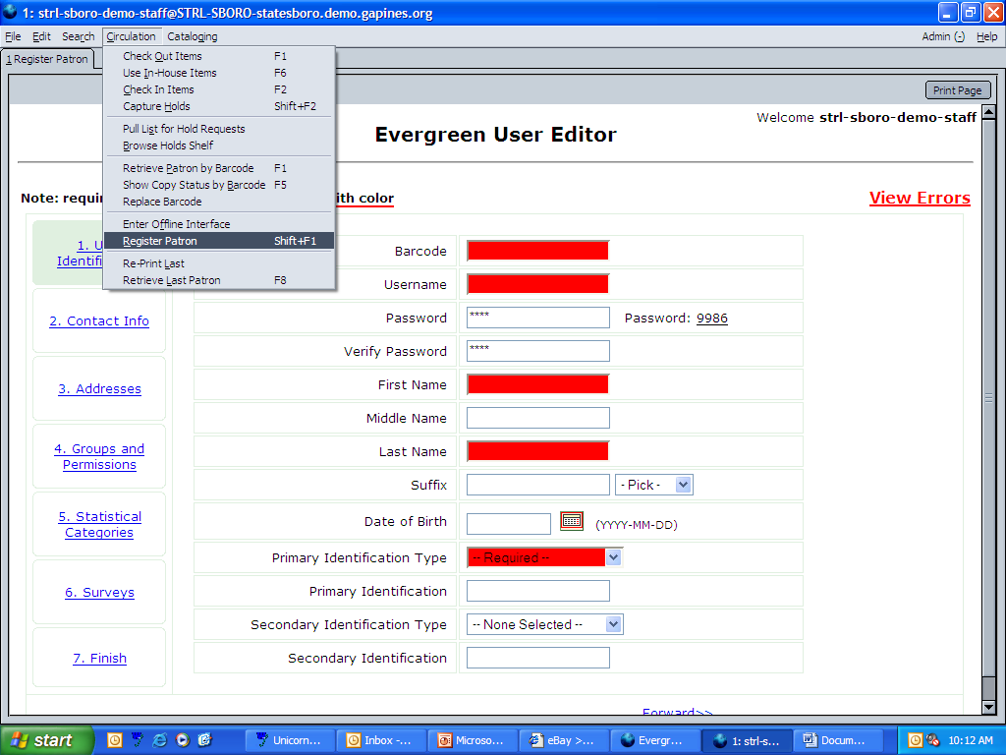
C. Patron Registration (Shift + F1)
a. Required fields (highlighted in red)
b. Explanation of user name, pin
c. Explanation of primary ID
d. Birth date (YYYY-MM-DD)
e. Mailing address, physical address
valid, city limits
- Profile
- Explanation of family group
- Statistical info
- Surveys
j. Create your own patron for practice

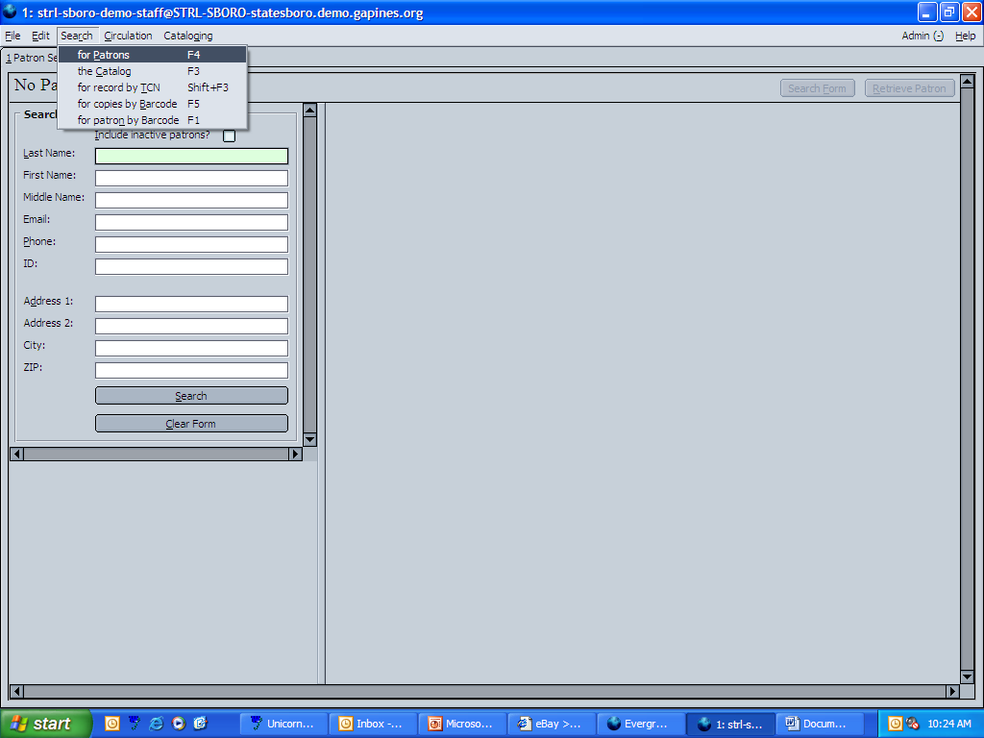
D. Searching for a Patron (F4)
a. Choice of fields to search
b. Choose fields to display
c. Type in last name Simpson
d. Look at the column selector
e. Retrieve patron (new tab opens)
f. Alert message (check here to confirm)
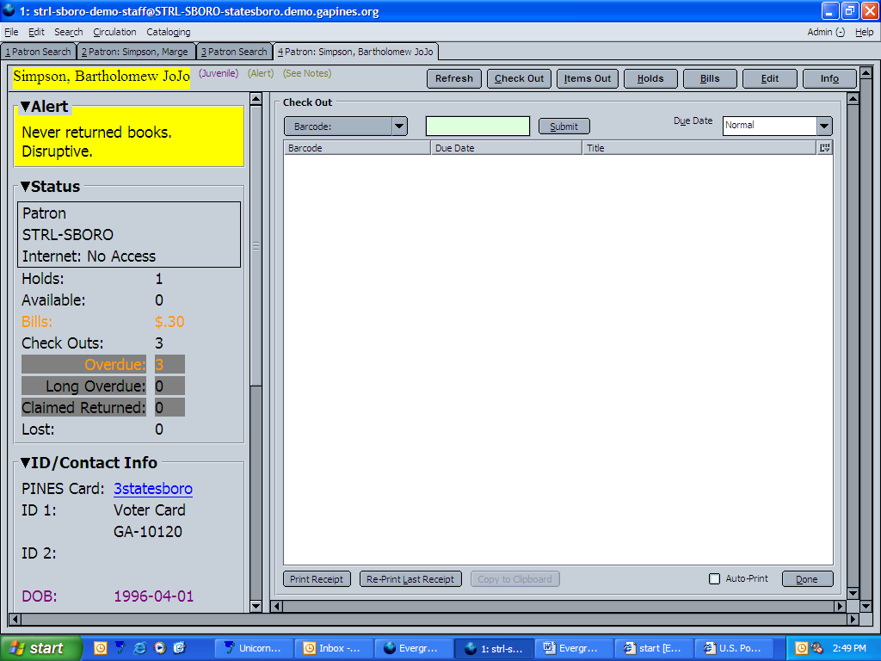
E. Check out (F1)
a. Set-up of
b. Color-coding
➢Green – OK
➢Yellow – Alerts
➢Orange – Fines & Fees
➢Purple – Blocked
➢Red – Barred
c. Barcode Box
➢Paperbacks
d. Due date
e. Column Selector
f. Forcing a checkout
g. Open circulation
h. Pre Catalog Field Entry
i. Print Receipt
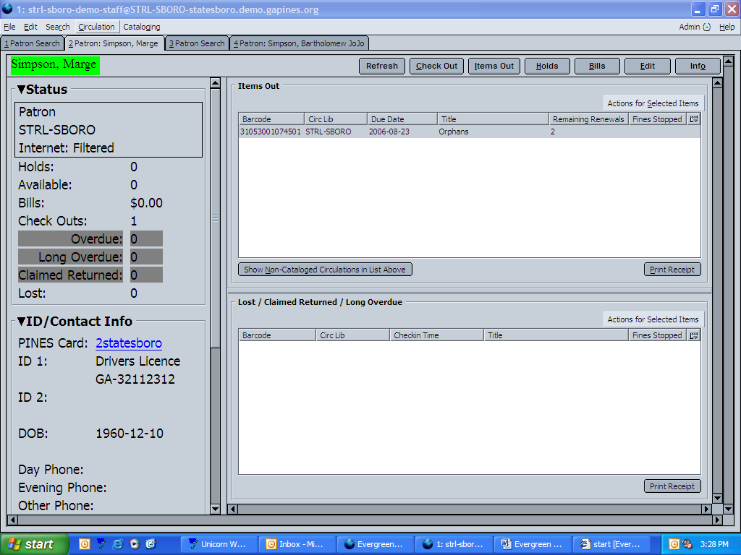

F. Items Out
a. Column Selector
b. Actions for Selected Items
➢Place to declare lost
➢Place for claims returned
c. Right Mouse Click
d. Print Receipt

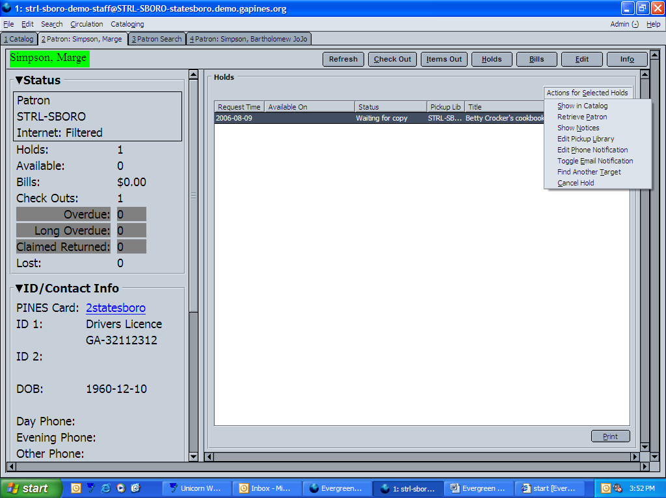
G. Holds Placed
a. Column Selector
b. Actions for Selected Holds
➢Show in Catalog
➢Retrieve Patron
➢Show Notices
➢Edit Pickup Library
➢Edit Phone Notification
➢Toggle E-mail Notification
➢Find Another Target
➢Cancel Hold

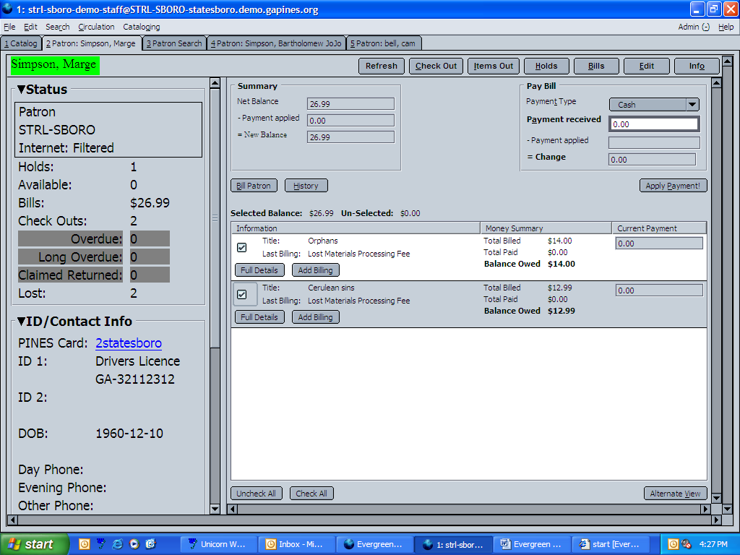
H. Bills
  - Payment Type
  - Payment Received
➢Can deduct individually
➢Otherwise will deduct
from top of bills
  - Bill Patron
  - Full Details
➢Voided = Our Fault
e. Add Billing
- History

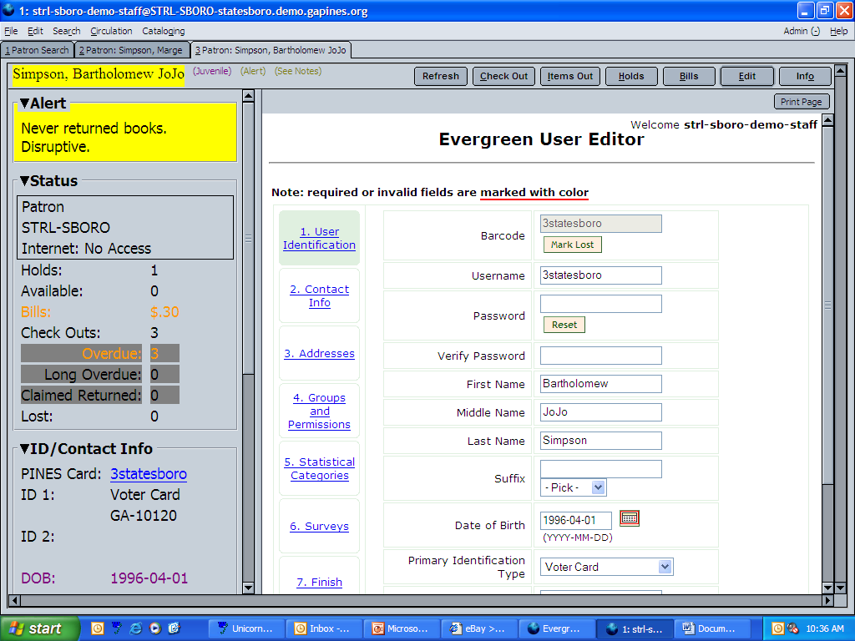
I. Edit Patron Record
  - Patron info on the left
  - Replace patron card number
  - Reset pin
  - Must go to finish and save!

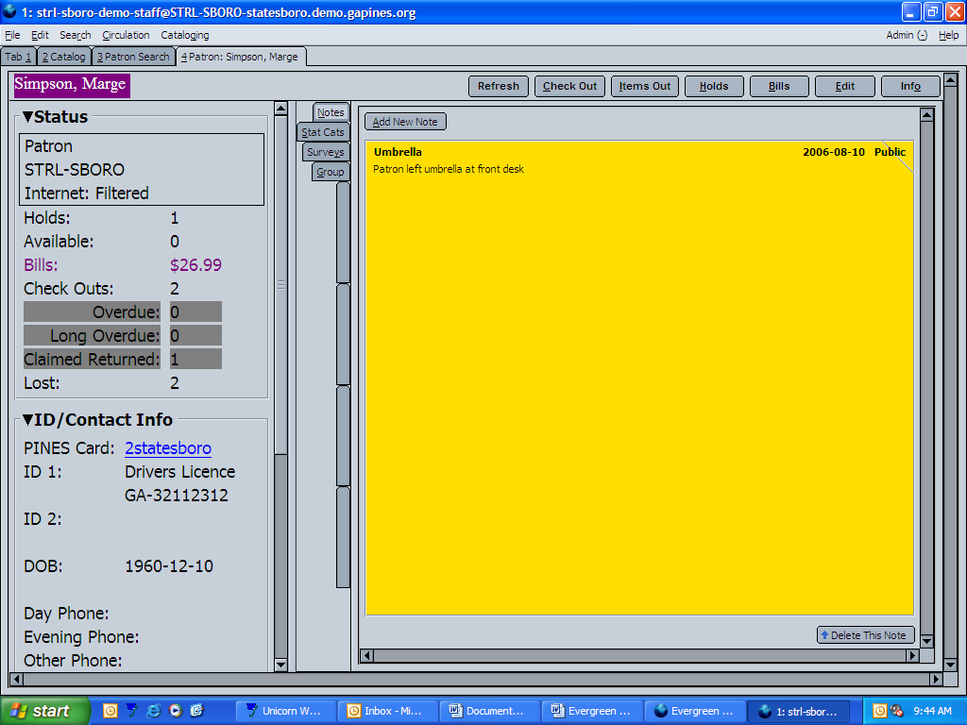
- Info
- Notes
➢Public vs. Staff Only
- Statistical Categories
- Surveys
- Group
➢shows if in group and
who is the leader (parent)
of the group

- Renewing Items or (F1)
a. Search for Patron by Barcode

- Check In (F2)
  - Effective Dates
  - Actions for Selected Items
➢ Show last few circulations

- Holds Step 1
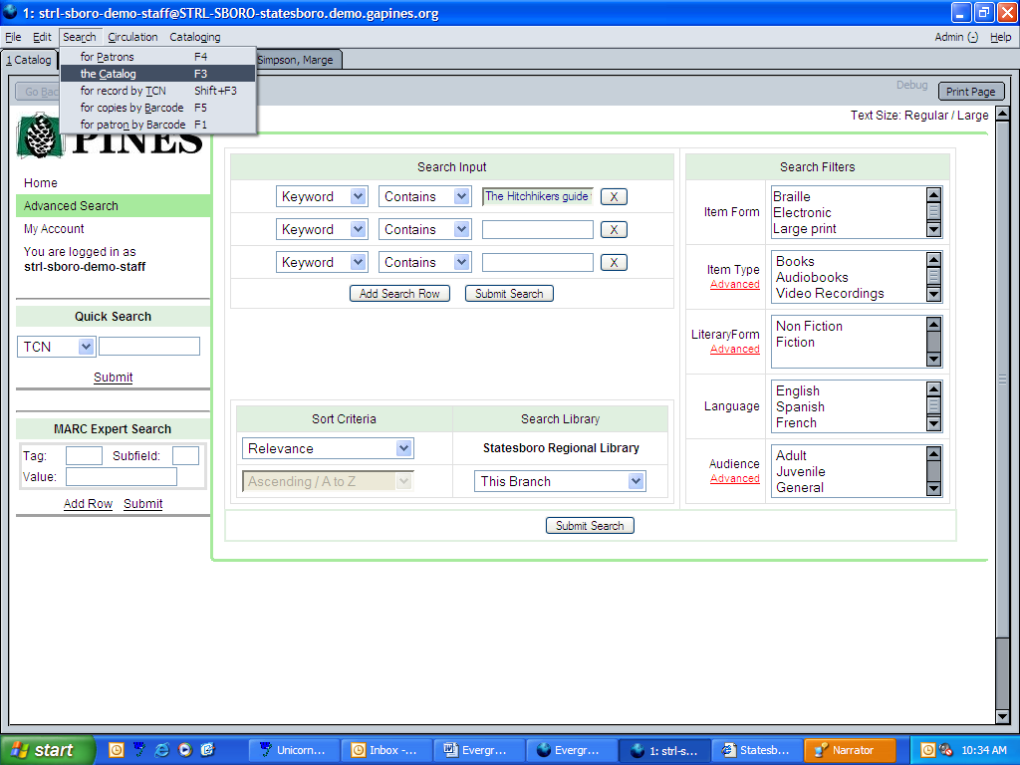
a. Placing a Hold

Step 1: Search the Catalog
➢ Type in Title/Author
➢ Select Location
➢ Submit Search

Step 2: Select the Item

Step 3: Click Place Hold

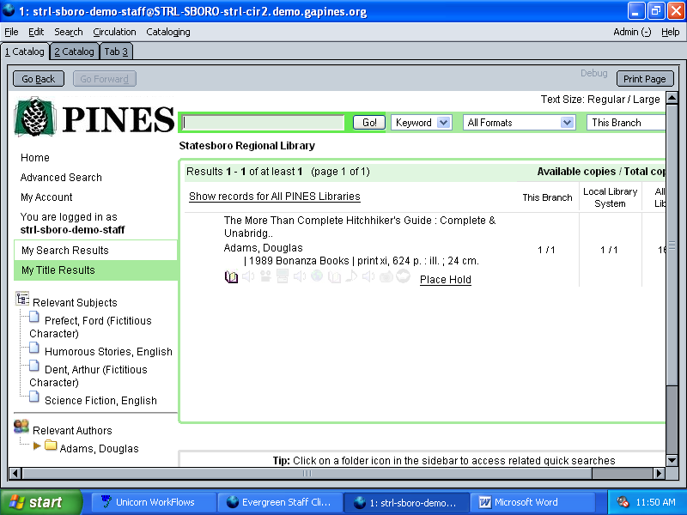
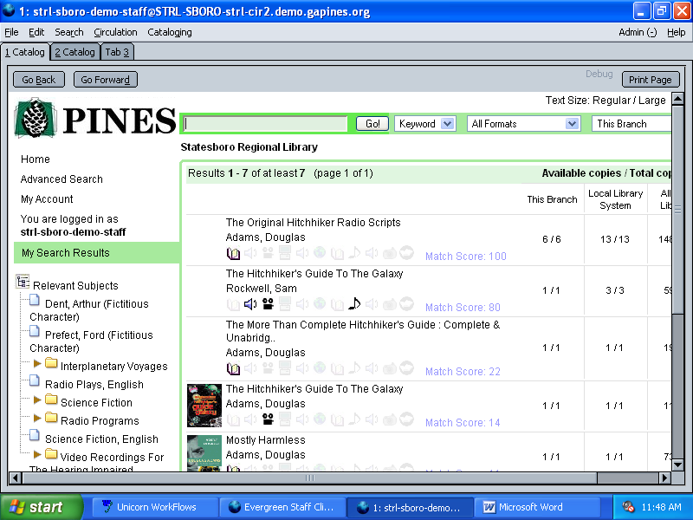
Step 2 Step 3
Step 3: Click Place
Step 4: Enter Patron Barcode Step 4
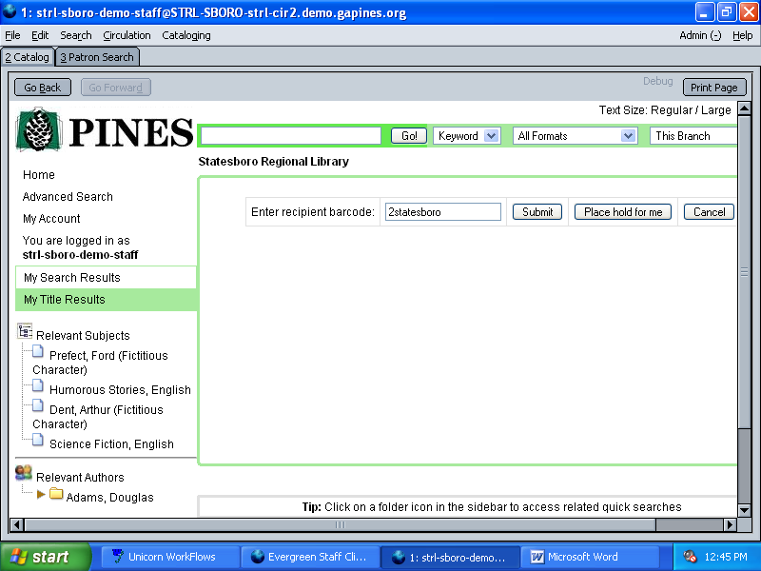
➢Open new tab and search
➢Highlight barcode number
Ctrl + c = copy
Ctrl + v = paste

Step 5: Create/Edit Hold
➢ Verify the info is correct
➢ Pickup Location
➢ Place Hold

Step 6: Hold Successfully Placed

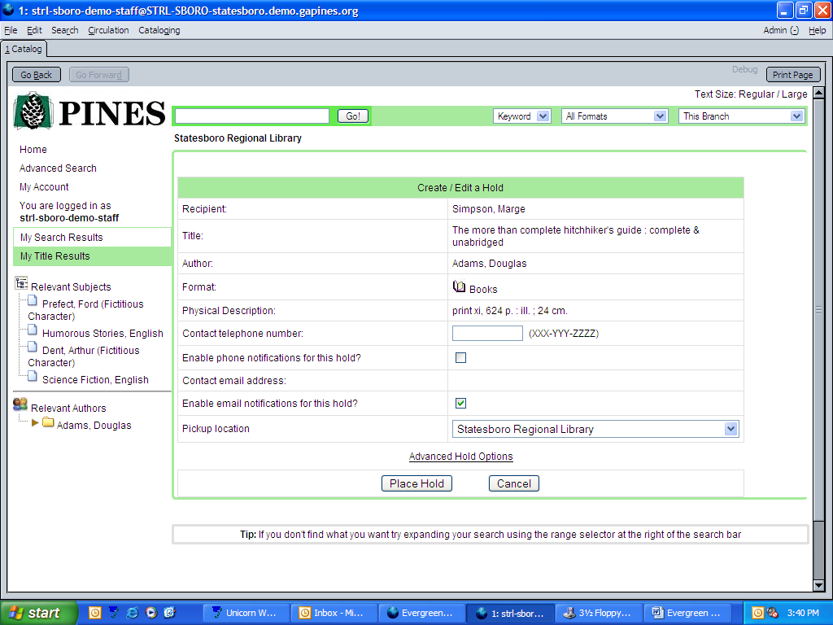
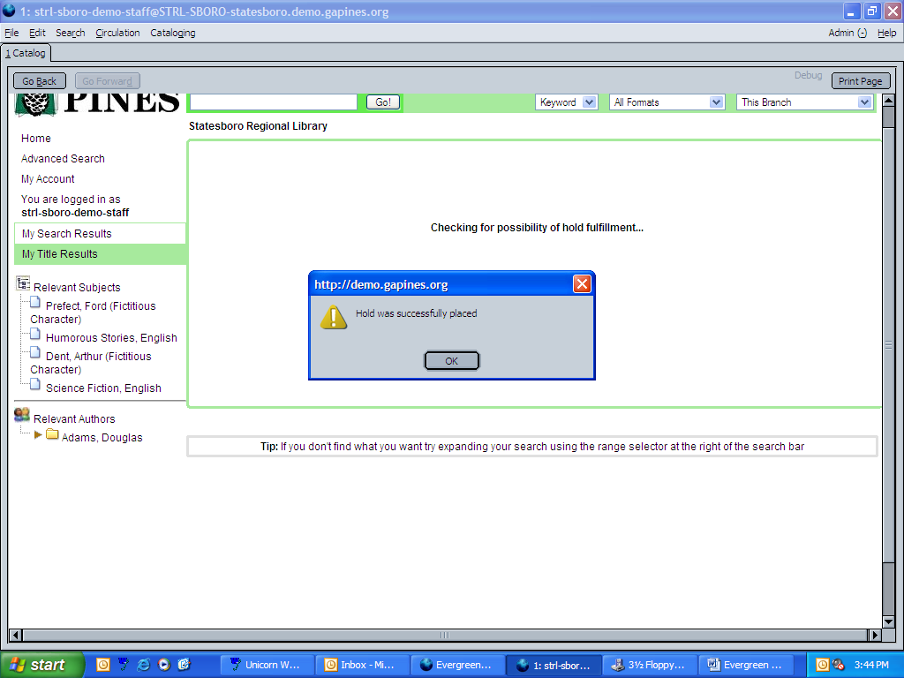
Step 5 Step 6

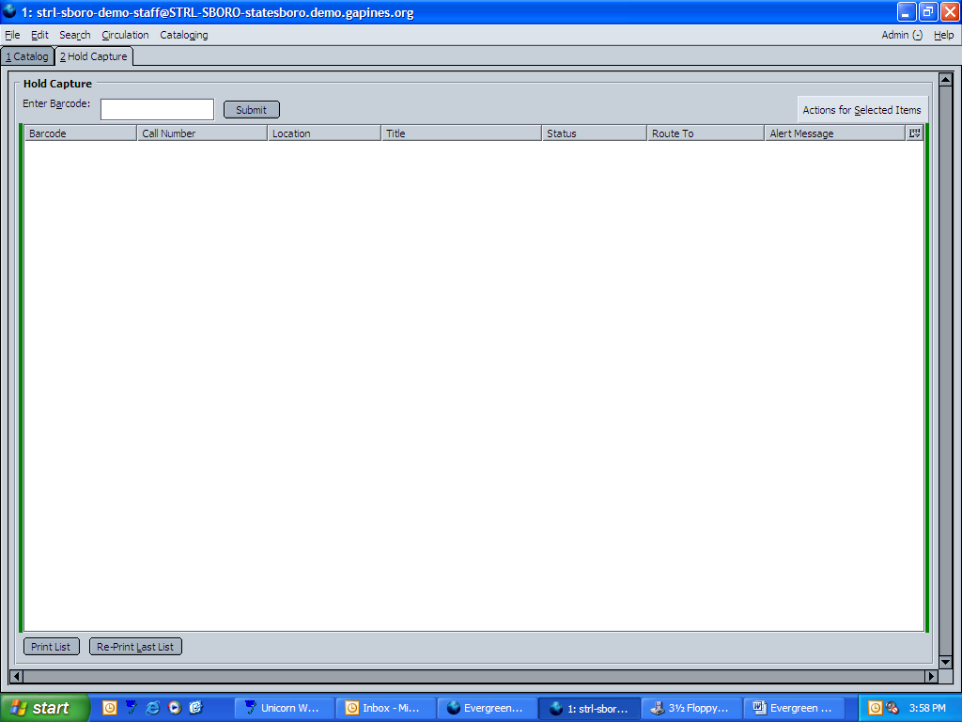
b. Capturing Holds (Shift + F2)
➢ Action for Selected Items
➢ Column Selector

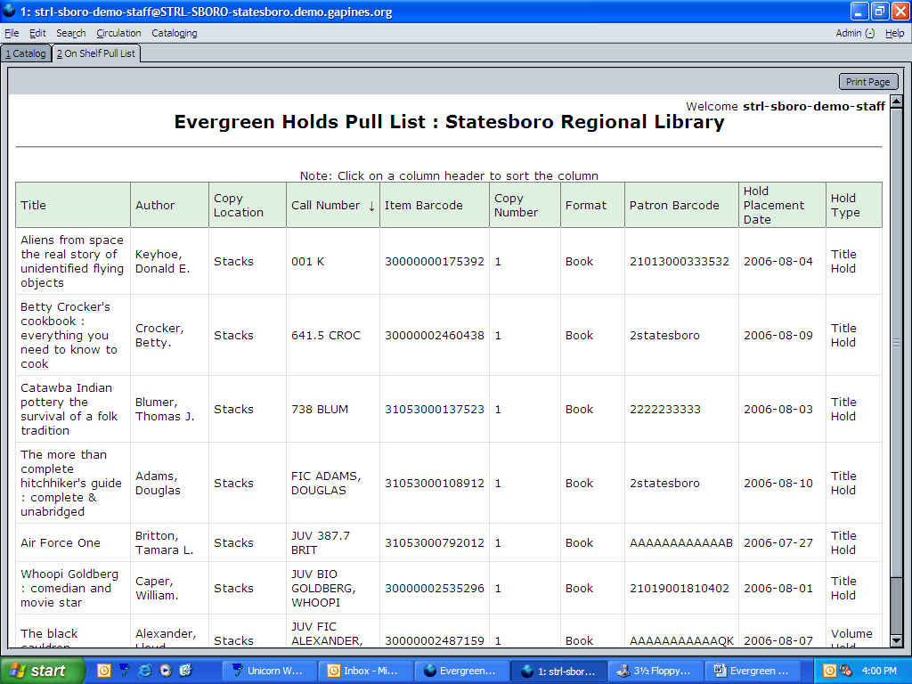
- Pull List for Holds
➢ Pull list directly from Evergreen
no longer have to go through
e-mail or website.

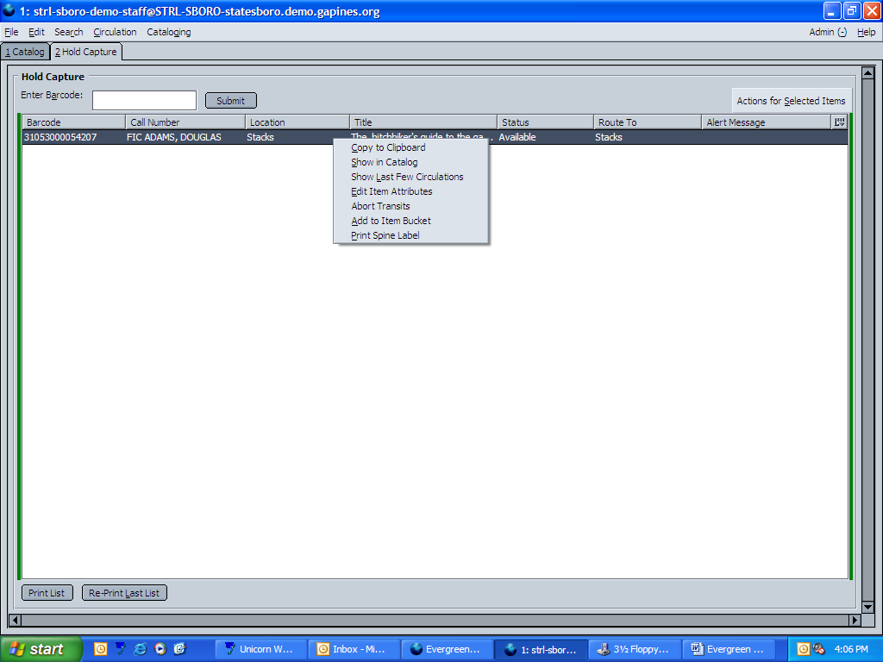
- Browse Holds Shelf
➢ Column Selector
➢ Actions for Selected Items

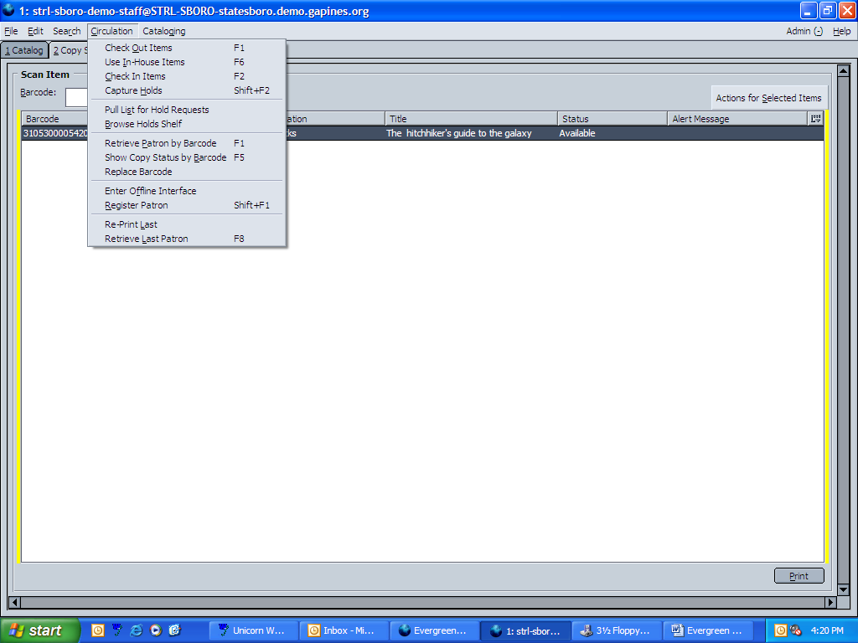
- Items Maintenance
  - Use In House Items
  - Show Copy Status by Barcode
  - Replace Barcode

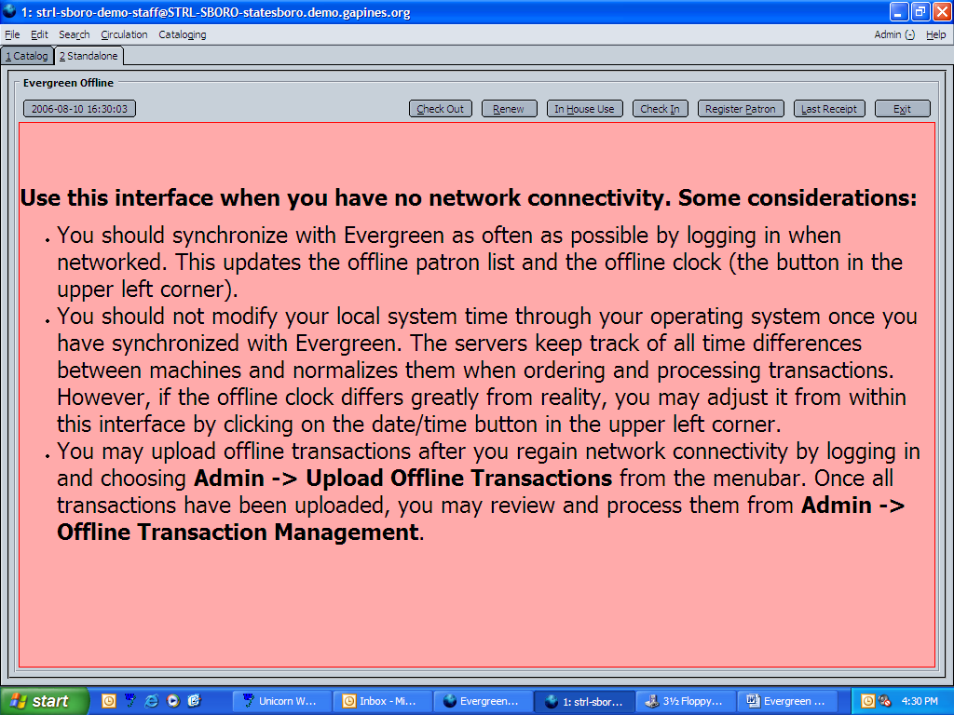
O. Offline Interface
  - Check Out
  - Renew
  - In-house Use
  - Register Patron
  - Last Receipt
  - Exit

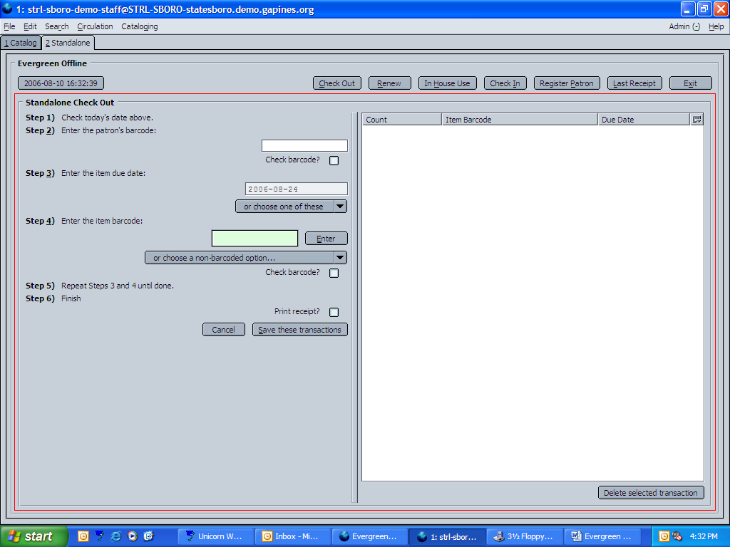

Questions?

