Self-training for Evergreen Electronic catalog – lesson 1

1. In Internet Explorer type in the URL: demo.gapines.org
Screen should look like this:

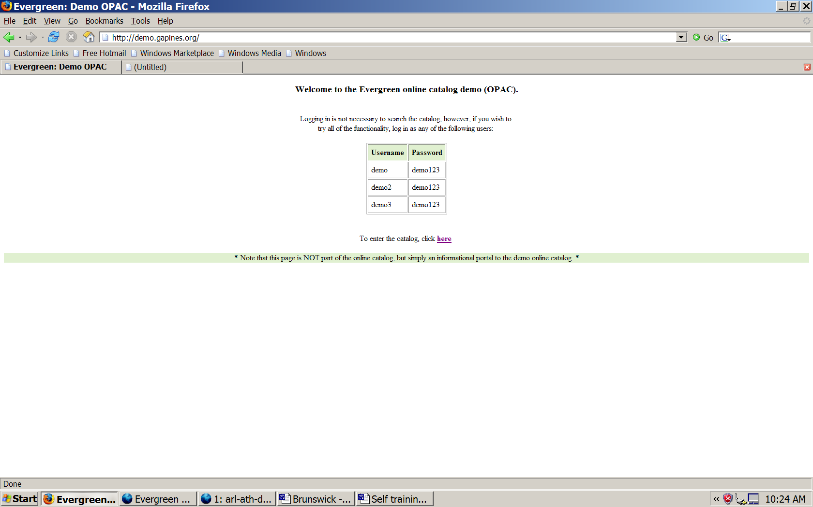

2. Click on the word here. The screen should look like this:

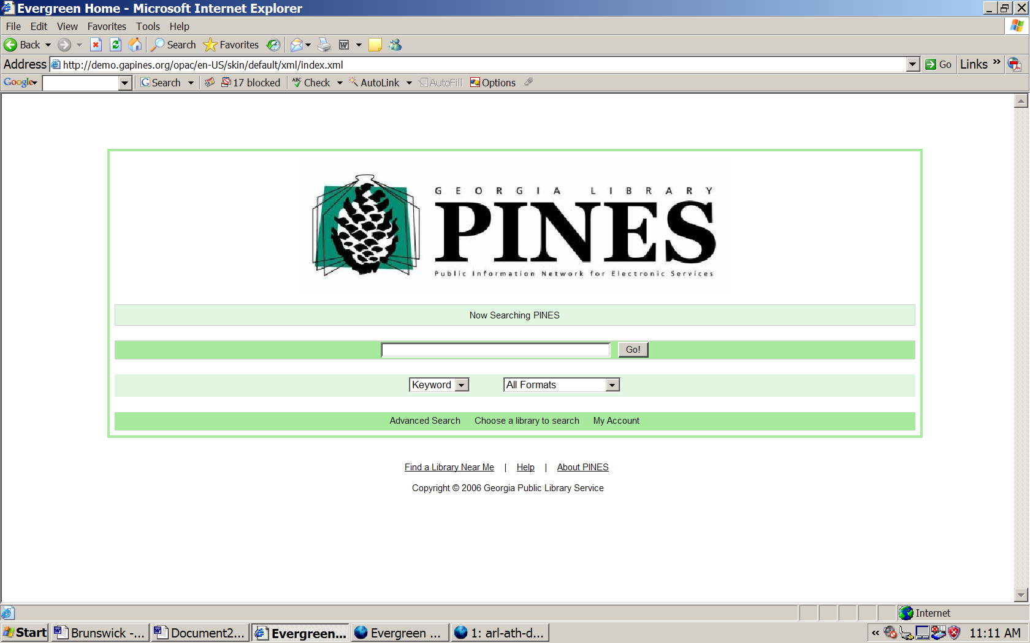

3. Look at all the different items or links on the page. Start at the bottom of the page:

Find a Library Near Me
Click on that link.
Screen should look like this:

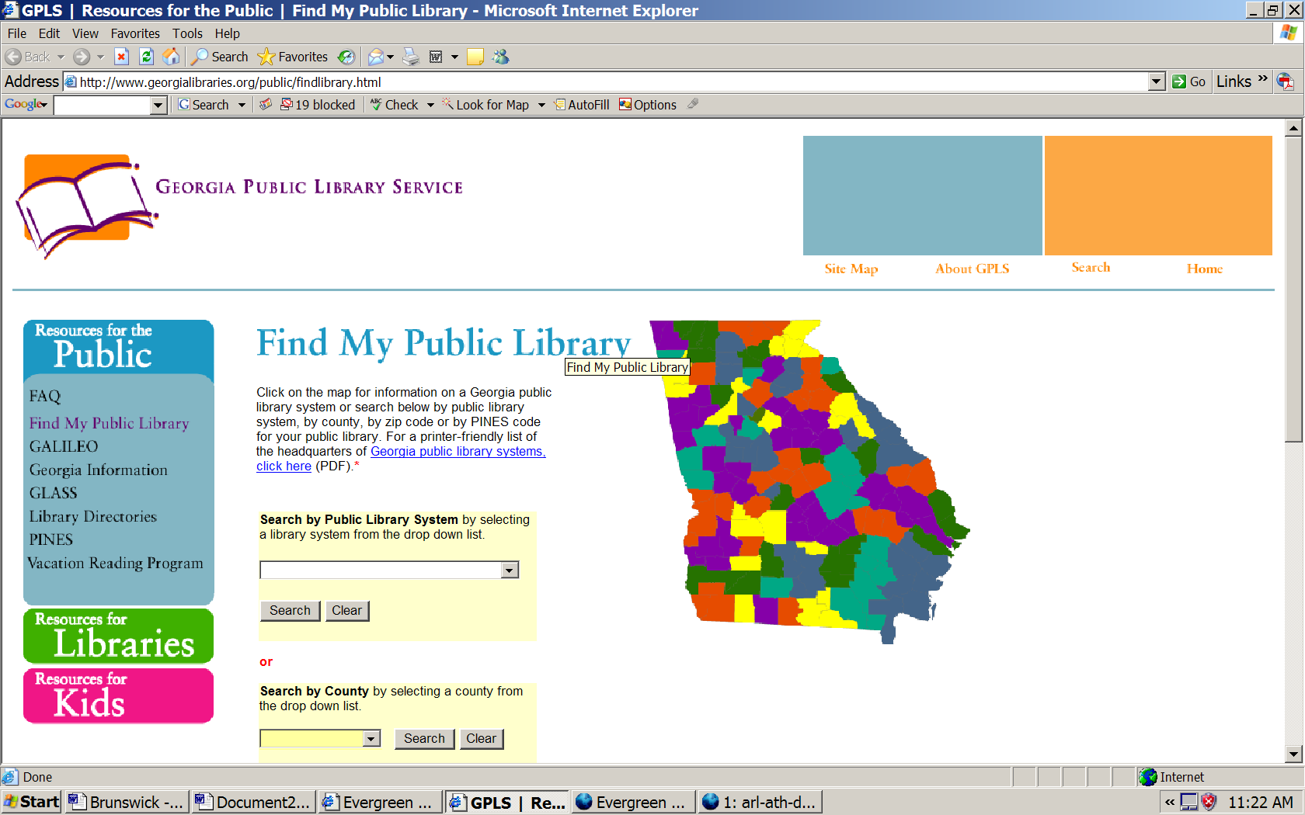
3. Scroll on this screen. Notice how you can find a public library.
SYSTEM

COUNTY
ZIPCODE
PINES CODE
OR geographically by choosing a system outline on the map

4. Look for the PEACH COUNTY LIBRARY SYSTEM using the SYSTEM search. Scroll down using the down arrow.
The screen should look like this:

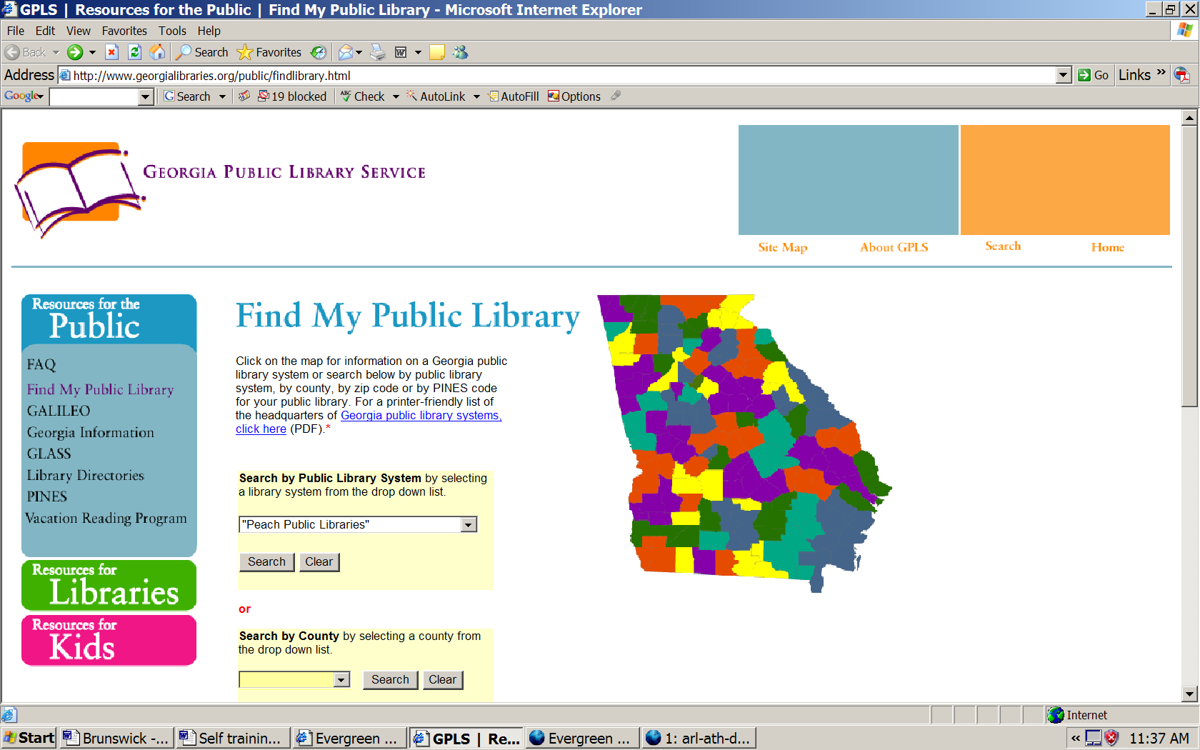

5. Click on SEARCH. The screen should look like this:

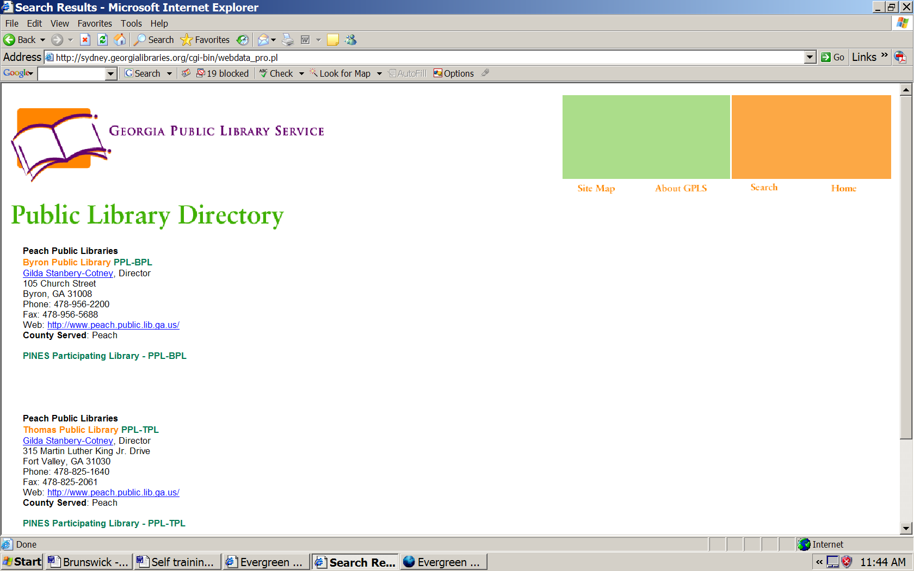
6. Using the BACK button on your search screen go back to the initial FIND MY PUBLIC LIBRARY screen. Click the CLEAR button under the system search button. THEN -- Use the additional abilities and similar instructions, find the answer to these questions:

- Of what library system is EARLY County a member?
- What library system is within 10 miles of zip code 30701?
- What library system has the PINES code TRRL-STMRY?
- What color is the Ohoopee Regional Library System on the map and what happens when you click on the link?

7. Return to the catalog page.
a. Click on the About PINES link. Where does it take it you?
  - Click on the Help link. Where does it take you?

8. Look in the bottom green line. Find “Choose a library to search.” Click on the link.
The screen should look like this:
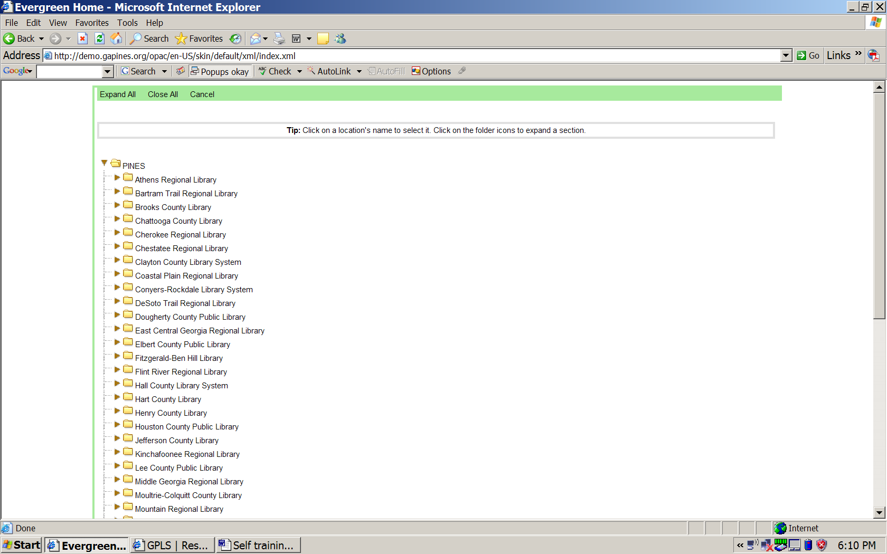

9. . This is a listing of all PINES library systems. Scroll up and down to see the entire list. Then, look in the top green line. Click on the link “Expand All.” The screen should look like this:
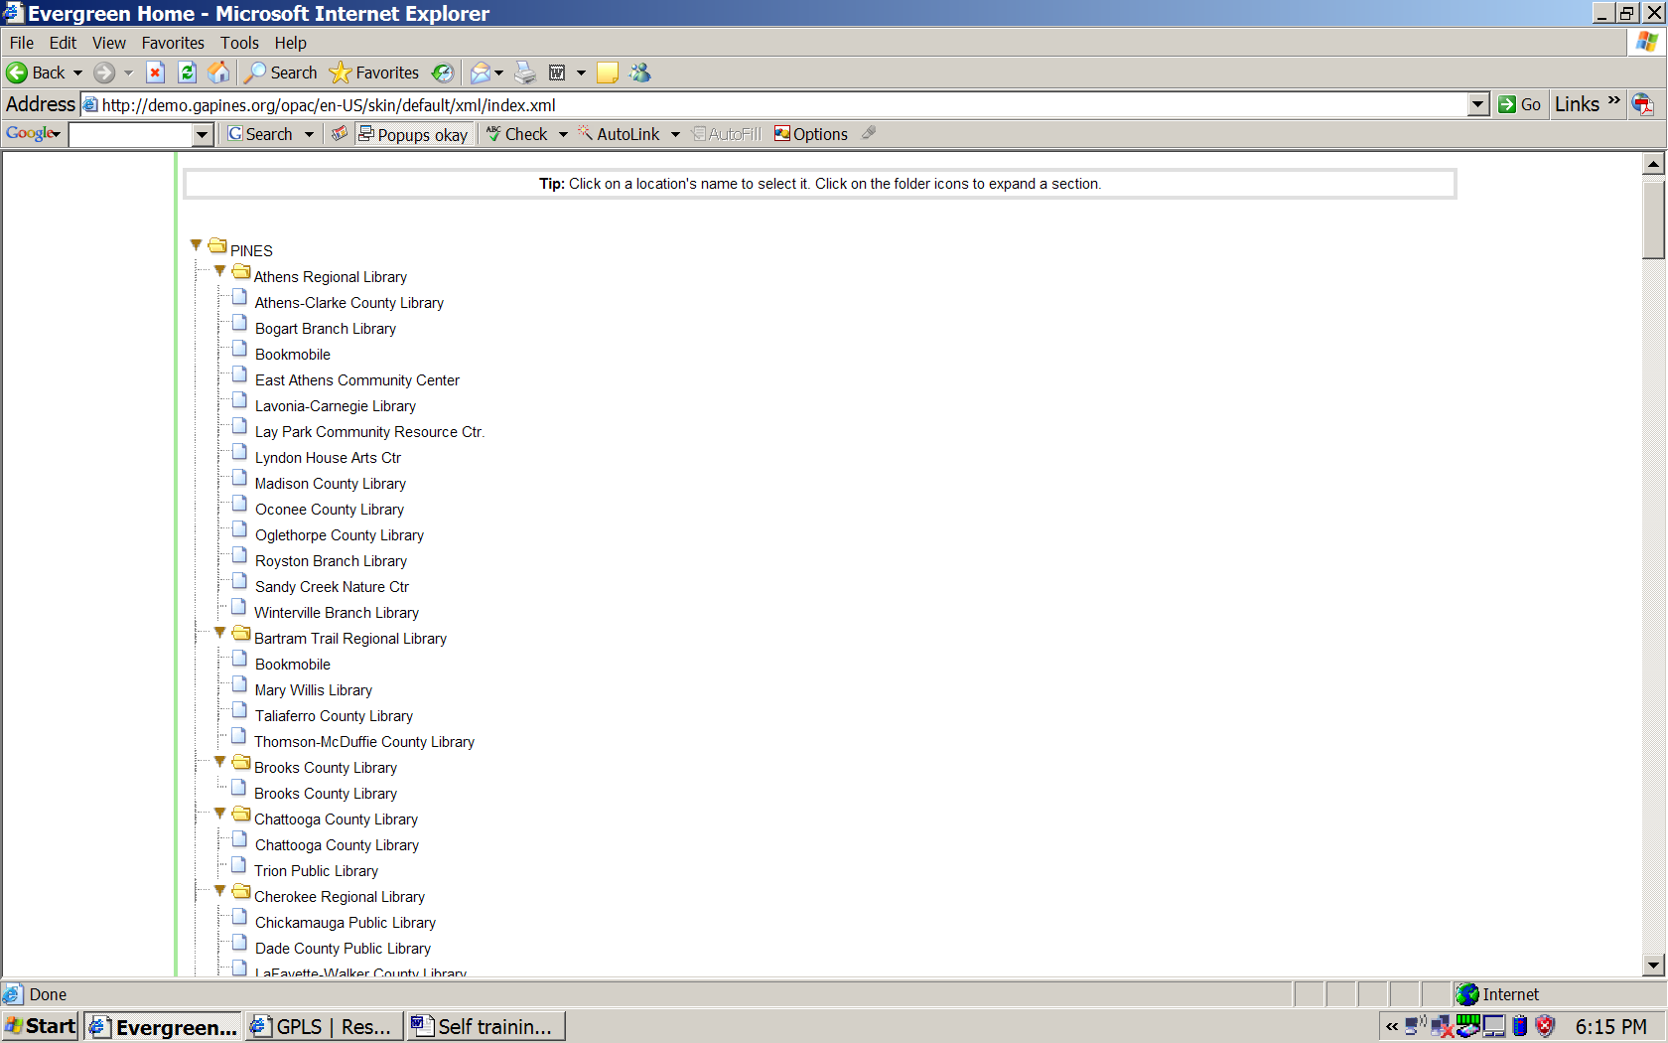

10. Click on the link “Close All.” Then scroll down to the Ohoopee Regional Library System line. Click on either the brown arrow OR the beige folder. The screen should look like this:
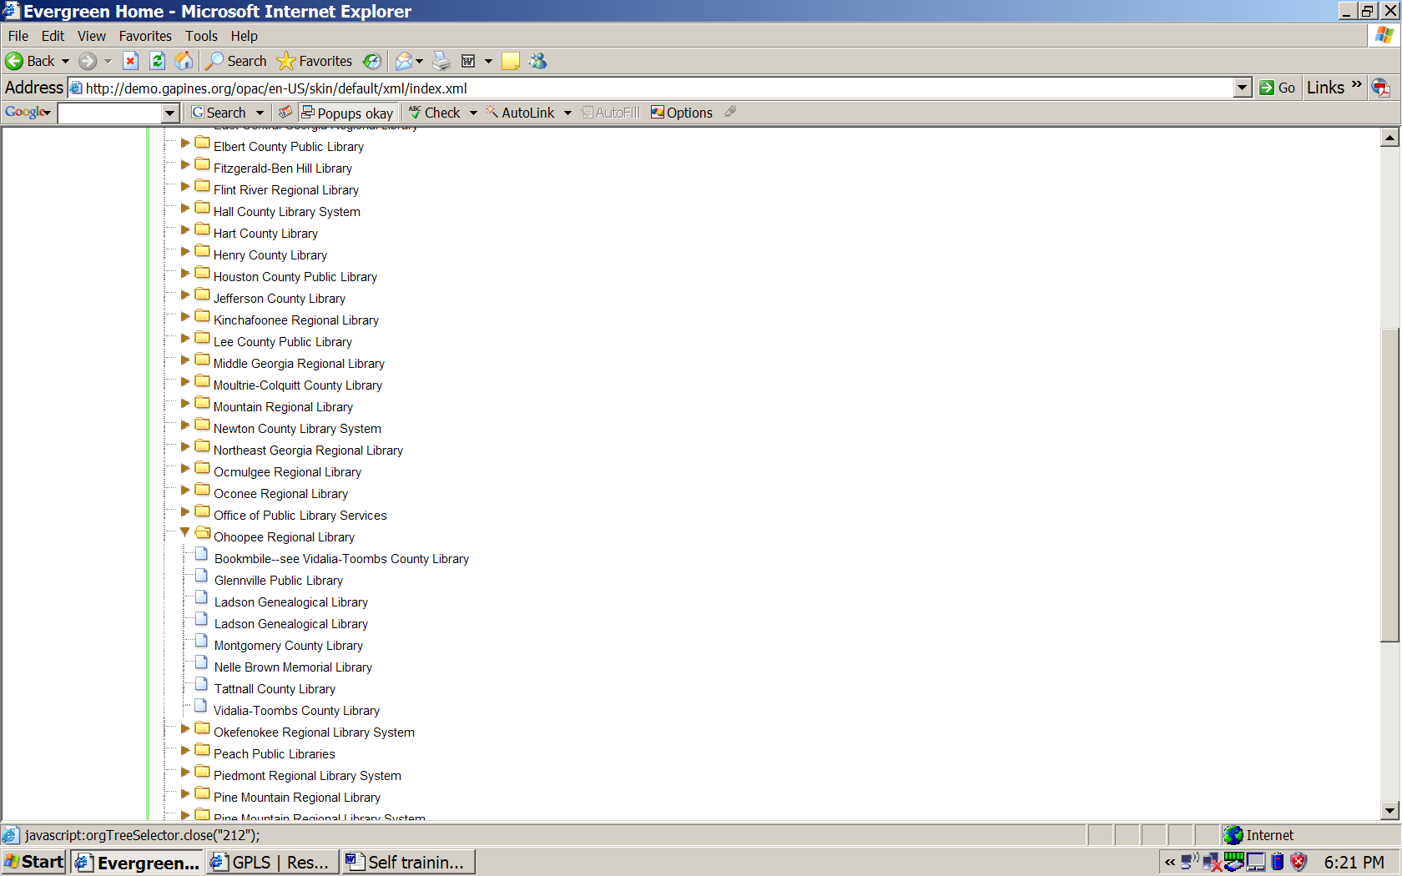

11. Click on the arrow or folder next to Ohoopee Regional Library System again. What happens?

12. Click on the Ohoopee Regional Library System line. The screen should look like this:
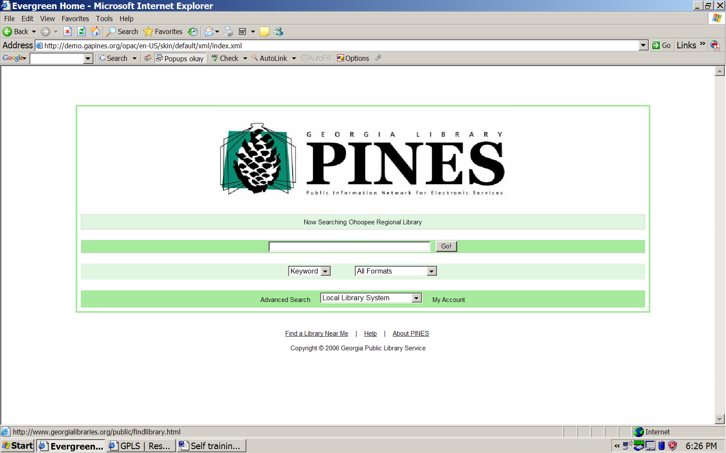
13. What items and information have CHANGED on this screen from the first screen?

14. Using the techniques above, change the search library to your own library branch. How will you know you have succeeded?

If your home library is Vidalia, the screen will look like this:
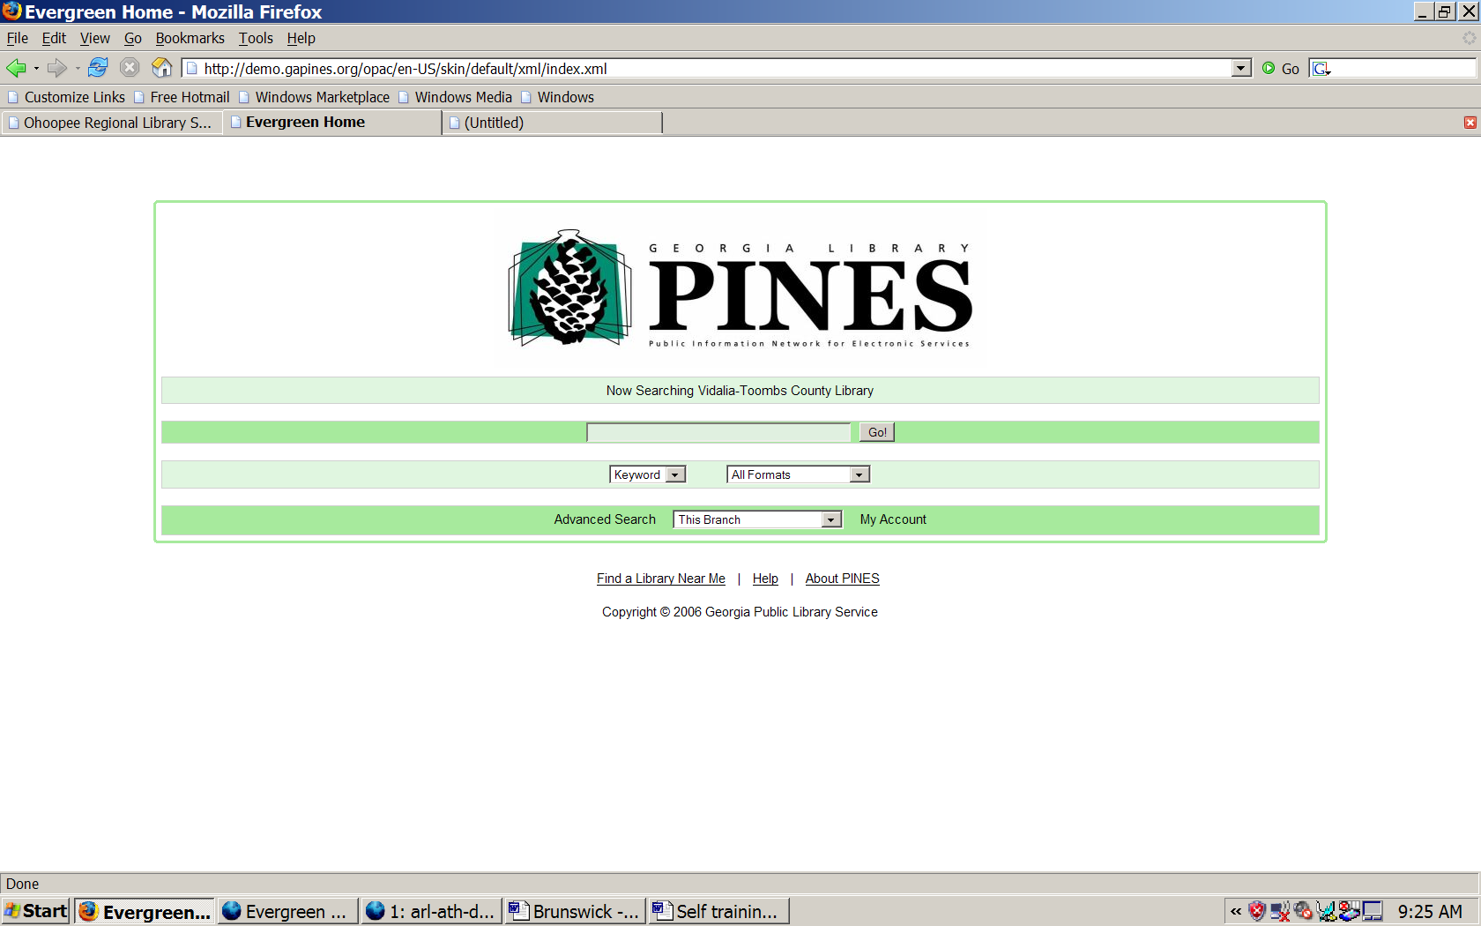

ANSWERS TO QUESTIONS

6. DeSoto Trail Regional Library
Northwest Georgia Regional Library
Three Rivers Regional Library System/St. Mary’s Library
Orange – go to our ORLS—Glennville Library listed first.

7. Georgia Public Library Service – PINES information.
Evergreen help screen. (Not complete yet).

11. It closes and you cannot see the individual libraries.

13. “Now searching Ohoopee Regional Library System” in middle line, changed from “Now Searching PINES.
“Local Library System” in white search line on the bottom, changed from “Choose a library to search.”

14. “Now searching _________ Library” in middle line, changed from “Now Searching Ohoopee Regional Library System”
“This Branch” in white search line on the bottom, changed from “Local Library System.”

