Self-training for Evergreen Electronic catalog – lesson 2

1. Using the demonstration URL open the Evergreen catalog page. Remember, after you enter it, it should look like this:
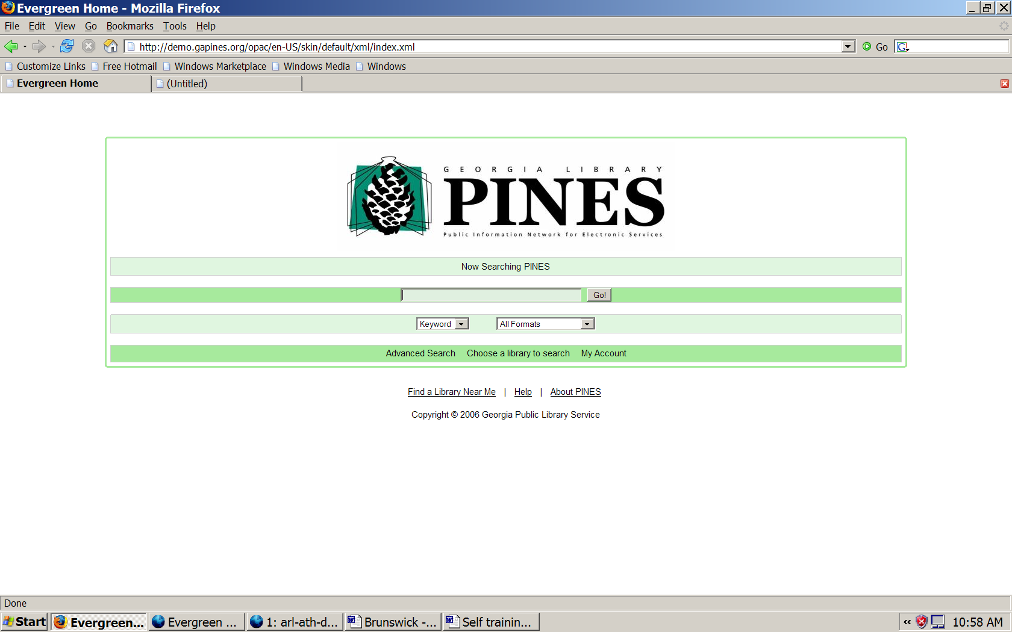

2. We will now do a simple search. Look at the search screen. We will be doing a Keyword search; All Formats. Make sure you find those words on the screen. Click on the down arrow next to Keyword.
  - What other choices show up?

Click on the down arrow next to All Formats.
  - What other choices show up?

3. Type in the subject “GOERGIA” (type exactly as spelled here). Click on Go! The screen should look like this:
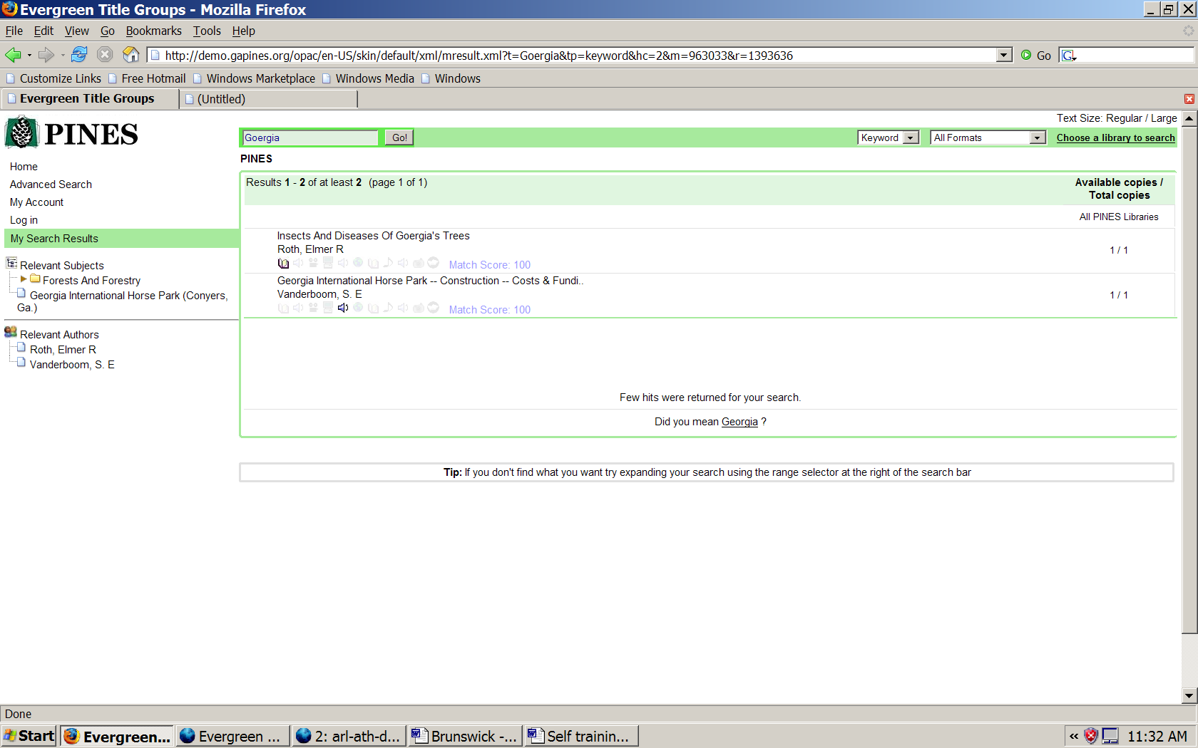

Two items have been incorrectly cataloged with the word GEORGIA misspelled. But, the system now asks you if you want to choose an alternative word or spelling. Since we really did mean to look up GEORGIA, click on the suggested link – the underlined word on the bottom message: “Did you mean Georgia?”
The screen should look like this:
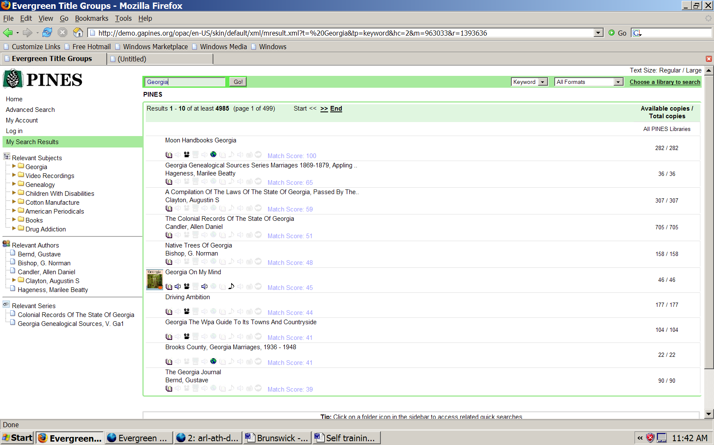

4. Look carefully at the screen and review all the information you can see.
Can you find the info to answer the questions:
- How many copies of Georgia On My Mind are in PINES?
- How many copies of Georgia On My Mind are available in PINES?

5. Look again at Georgia On My Mind. This record is a metarecord. That means that it is one listing or record that contains a lot of other listings or records. Look at the symbols underneath the title.
- What symbols are shown?
Gently move your mouse pointer over these symbols without clicking.
- What explanation shows up for each symbol?
The metarecord for that title contains the records of all those different item types.
6. At this time look at the upper right hand corner of the page. What happens when you click on large and regular next to the phrase Text Size: ?
7. Look again at the screen. Look at the left hand column. (Page repeated)
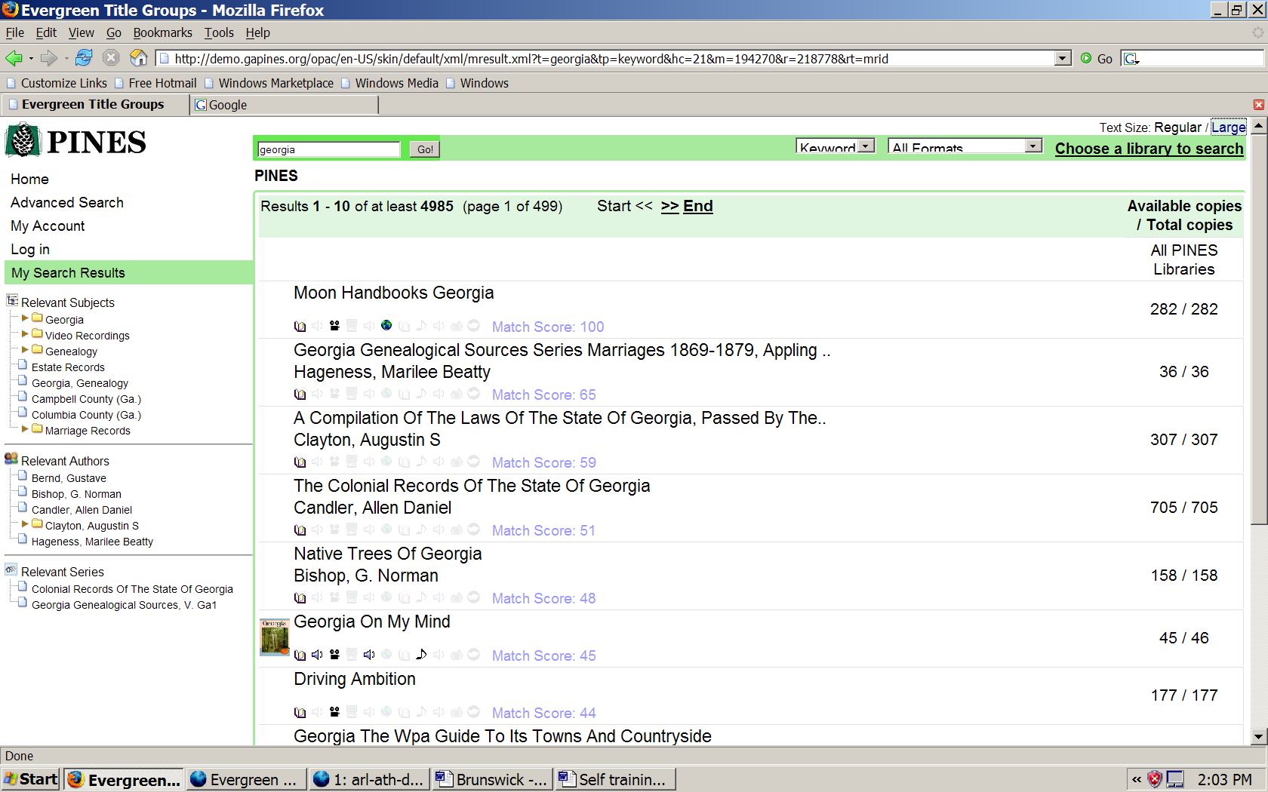

To help you narrow down a search the system offers other subjects and authors as a possible help. These lists are called Relevant Subjects, Relevant Authors, Relevant Series. Somewhere on this screen is a note to the user also explaining this column. Find the note.

a. Where is it and what does it say?
Also in this column you can see where you are in the search process. Look at the line that is highlighted green.
b. What does it say?

8. When you run the mouse pointer over the title Georgia On My Mind it changes color and becomes underlined. It is a link to the full record. Click on Georgia On My Mind.
The screen should look like this:
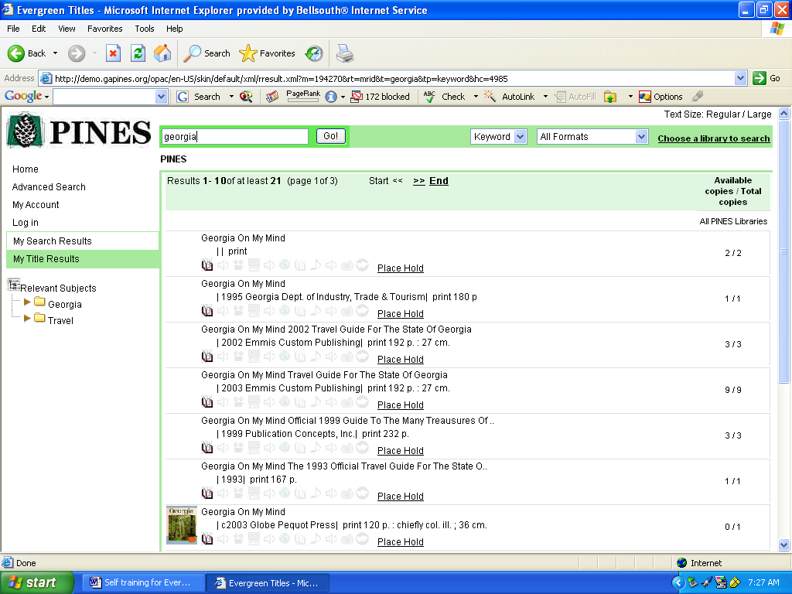

9. Look at the highlighted green line that tells you where you are in the Search process. How has it changed?

10. Using the drop down menu at the top of the screen, change formats to Music. Click the GO! button on the screen or hit <enter> on the computer. The screen should look like this:

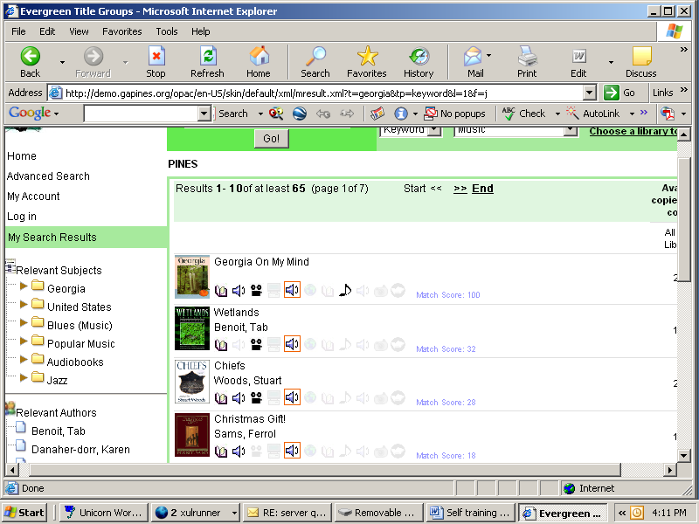

11. How does the listing show what type of format you chose? Click on the note symbol. The screen should look like this:
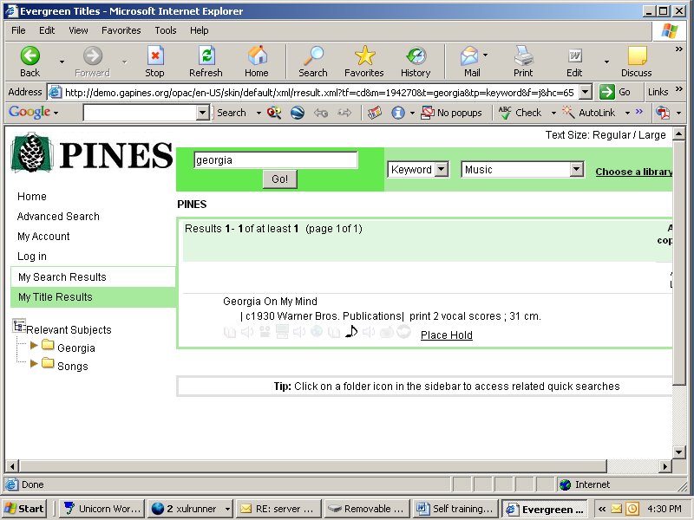

Click on the Item title Georgia On My Mind. The screen should look like this:
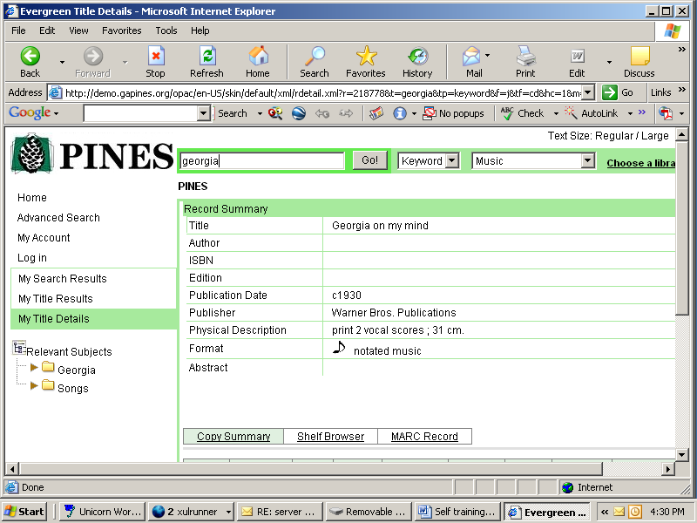

12. a. On what level are you now according to your search?
Look at the bottom of the search screen. You have a choice of three viewing levels. You are on Copy Summary.
b. How do you know that is where the search has taken you?
c. What information does the copy summary give you?
d. Click on details. What specific additional information is shown?

13. Click on HOME – not in your browser, but on the search screen, upper left hand corner.
a. Where does this take you?
b. What do you see on the screen that you should be aware of and caution the patrons about?

******************************************

ANSWERS
2. Keyword; Title; Author; Subject; Series
All Formats; Books; Large Print Books; Audiobooks; Video Recordings; Music; Electronic Resources
4. Right hand column. There are 46 copies in PINES. Looking at the screen photo in this document there are 46 available. The number will be different if there are some checked out, or otherwise marked.

5a. book, speaker, projector, speaker, musical note.

b.text, sound recording-nonmusical, moving image, sound recording-musical, notated music

6. Differing size of the font on the screen – large print and regular.

7. a. Line on the bottom center of the page. Tip: Click on a folder icon in the sidebar to access related quick searches

b. My Search Results

9. My Title Results

11. Speaker icon highlighted.

12. a. My Title Details
b. Copy Summary is highlighted in green
c. Owned by Vidalia-Toombs County Library, Call number is R782.42GEO, 1 copy is available.
d. barcode #

13. a. Back to the initial PINES screen.
b. The last search remains listed. Until a “clear” button is installed, caution patrons about clearing their search so their info or subject can remain private.

