Self-training for Evergreen Electronic catalog – lesson 3

1. Using the demonstration URL open the Evergreen catalog page. Choose the Vidalia-Toombs County Library to search. Choose AUTHOR as the search type and LARGE PRINT as the format. Enter the author Mary Higgins Clark. (NOTE: You do not have to type in the author’s last name first. You may type it in as given above.)
The screen should look like this:
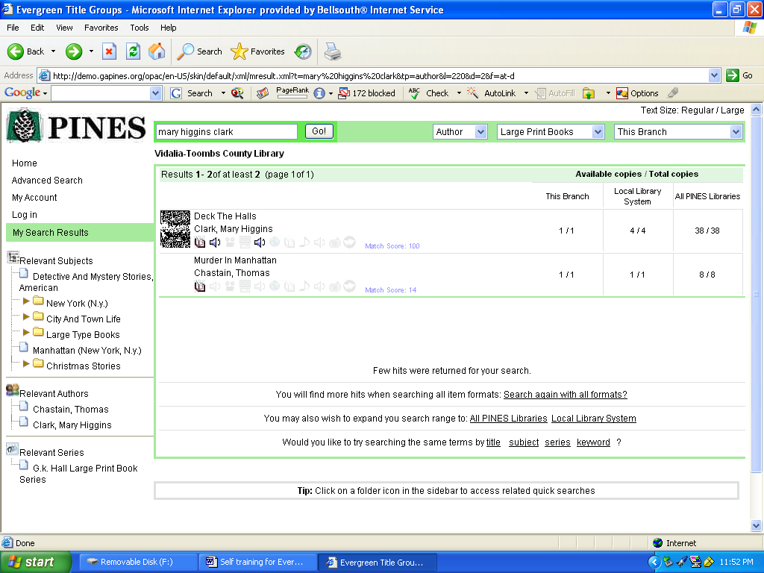

a. How many copies does Vidalia have of the large print book, Deck The Halls by Mary Higgins Clark?
b. How many copies does the Ohoopee Regional Library System have of the same book?
c. How many copies are in PINES?
d. What suggestions does the catalog give you to find more titles?
e. How can you choose the suggestions?

2. Click on Deck The Halls. The screen should look like this:
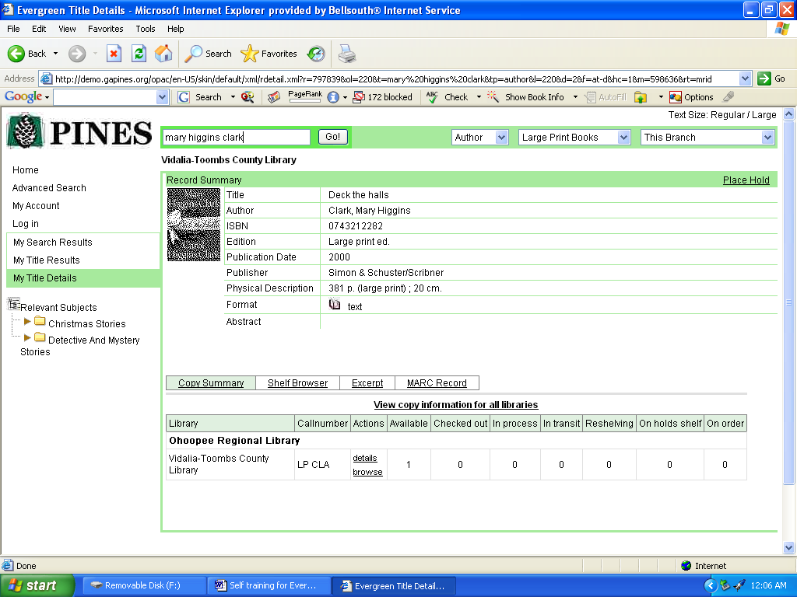
a. How do you find the bar code number of this book? What is it?

3. Click on the command link Shelf Browser.
a. What do you see?

4. Click on the command link Excerpt.
a. What do you see?

5. Go back Home. Do a new search to answer the question:
What books in the Wagons West series does Glennville Public Library have?

6. After you have searched, the results screen should look like this:
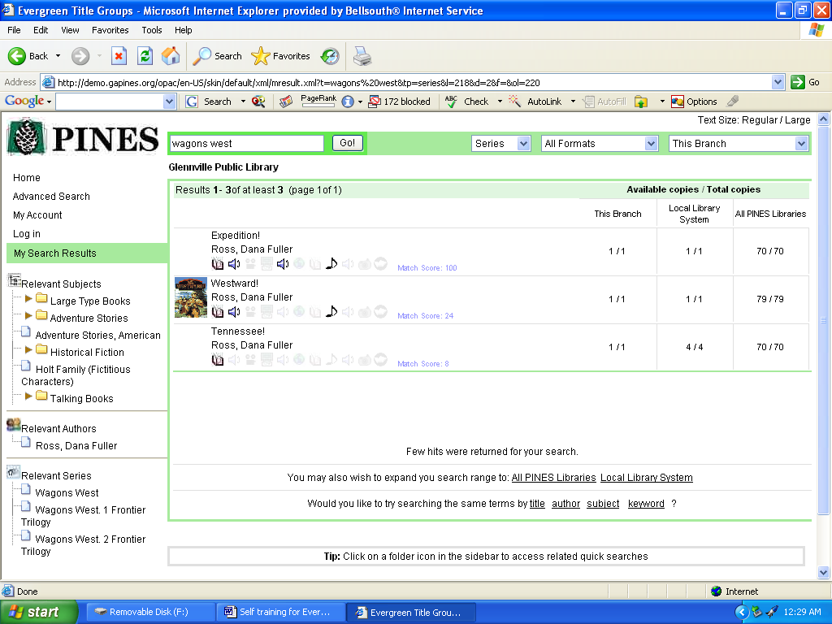

Expand your search range to include the Local Library System. The screen should look like this:
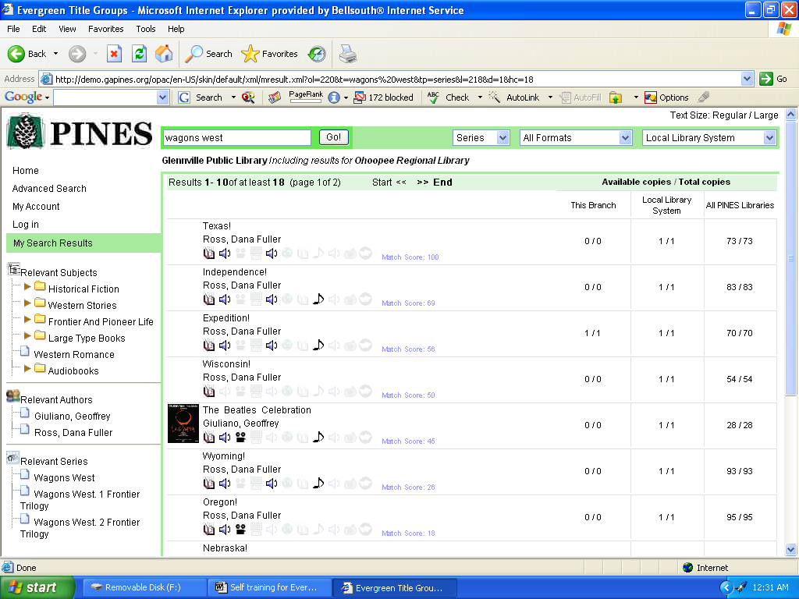
a. Where does it tell you what branch and what system you are now searching?

7. Look up the book, Ecology of a Cracker Childhood.
a. How many copies are available in the Montgomery County Library? In the Ohoopee Regional Library System?
This is an expanded record. Records for newer books (usually 5 years old or less) will have this type of record.
b. What magazines are listed as having reviews for this book?
c. What bird has a chapter in her book?

8. Look up To Kill a Mockingbird for the Ohoopee Regional Library System. Find the record for the 1960 (1st.) edition.
Get to this screen:
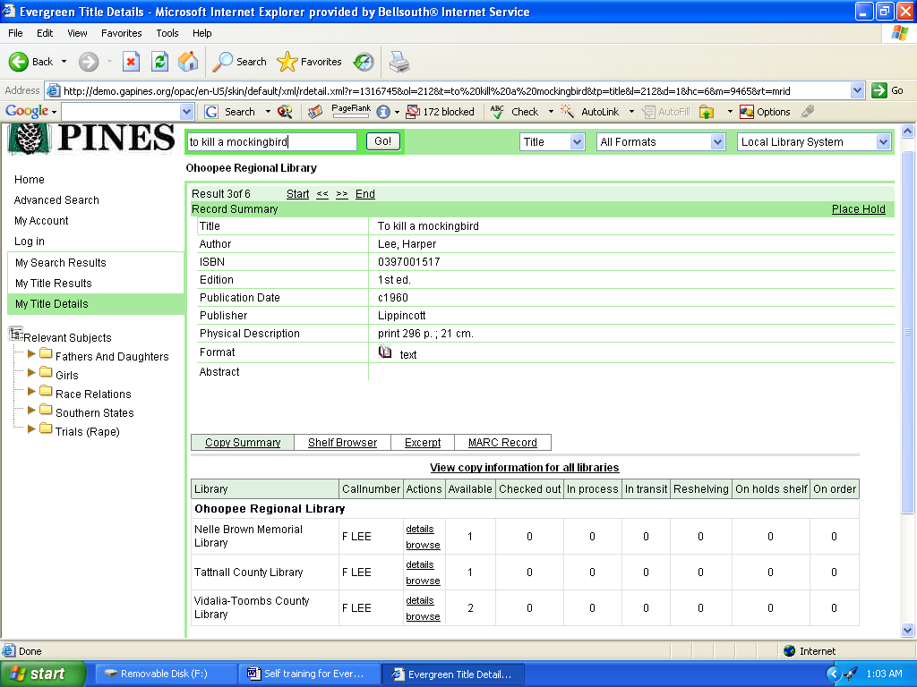
You are now looking at the copy information for Ohoopee Regional Library System.
a. What link would you use to view the same type of copy information for all of PINES? (Notice that all Systems and Branches are now written out instead of the PINES code.)
b. What link do you use to view only the Ohoopee Regional Library System?

9. a. Which link or record in the To Kill a Mockingbird search was the metarecord you used to find the requested volume?
b. How many different records were in the metarecord?

ANSWERS
1. A. 1
b. 4
c. 38
d. You will find more hits when searching all item formats: Search again with all formats?; You may also wish to expand you search range to: All PINES LibrariesLocal Library System; Would you like to try searching the same terms by title author subject series keyword ?
e. The underlined words are hyperlinks – you can click on them.

2. a. Click on details. 31041005084162

3. The books shelved before and after that call number on the shelf.

4. An excerpt from the book.

5. The search screen should have looked like this:
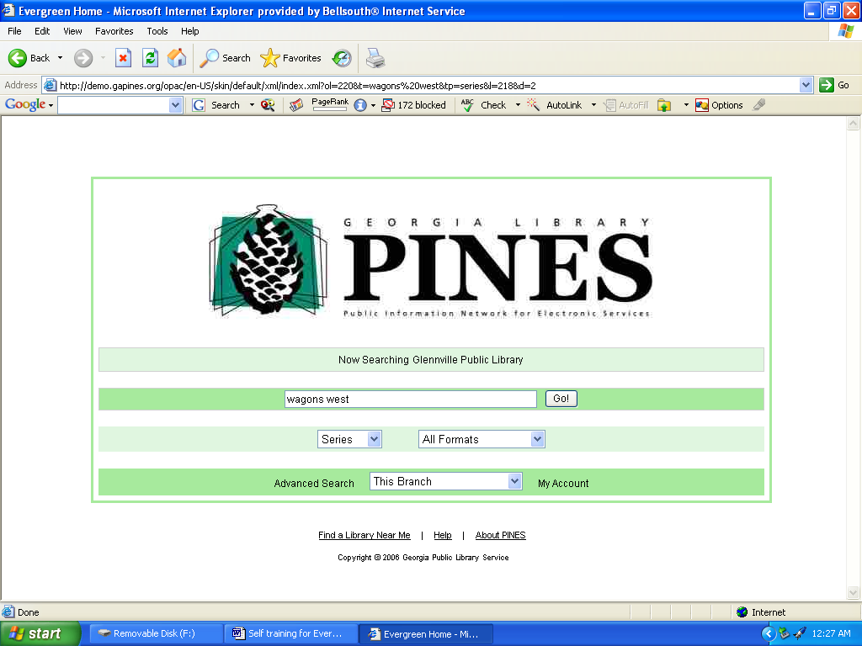

6. a. Top of the screen: Glennville Public Library Including results for Ohoopee Regional Library

7. a. 1; 7, two different editions
b. Publisher’s Weekly, Booklist, Library Journal
c. Bachman’s Sparrow

8. a. View copy information for all libraries
b. View Copy Information for this location only View copy information for all libraries

9. a. The first title listed on this screen:
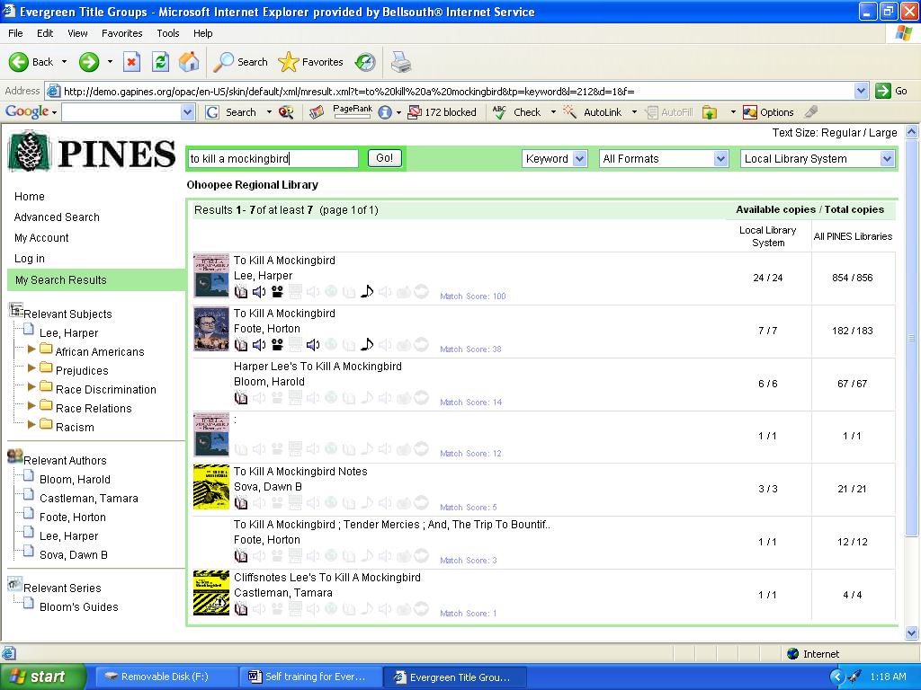

b. 6

