Self-training for Evergreen Electronic catalog – lesson 4

This will use the Advanced Search feature. We will go over additional parts of this feature during training.

1. Before you begin using the demonstration catalog, use the regular PINES catalog (http://pines.public.lib.ga.us), through the link on our website, or the patron public catalog. Do a title search, Vidalia-Toombs County Library, for these two titles:
A. Touch Not The Cat by Mary Stewart
a. How many records were found? b. Was that title found?
B. Bud, Not Buddy by Christopher Curtis
c. How many records were found? d. Was that title found?
C. Use ALL libraries and a title search for: And Quiet Flows The Don by Mikhail Sholokhov
e. What was the error message?

2. Now go to the Evergreen catalog, (http://demo.gapines.org) as previously demonstrated in Lessons 1-3. Do the same three searches, using Simple search, the same format as above: title search, Vidalia for A & B; title search, All for C. Answer the same questions for a, b, c, d, and what happens for e?

3. Can you guess why the difference in the search results?

4. At the Evergreen/PINES home search screen, click on Advanced Search.
The screen should look like this:
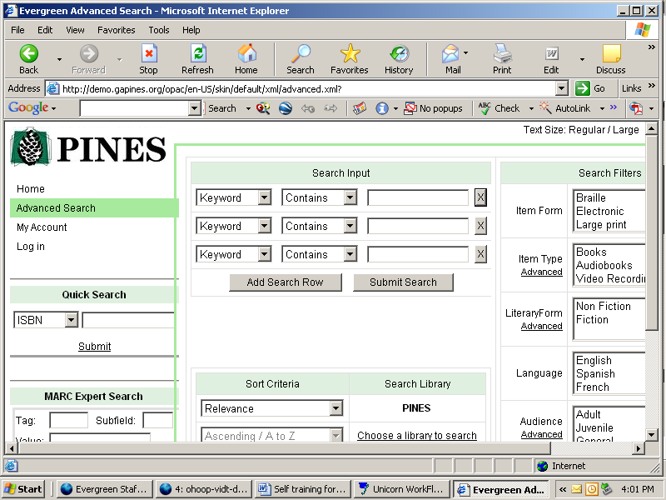
This is the search screen that will be viewed when you access the catalog from the circulation program.
Note the different headings and terms. There are six.
a. Name them all.
b. How do you know they are main headings or sections?

5. To look for a book in Spanish on pregnancy at the Ohoopee Regional Library System,
your search screen would look like this:
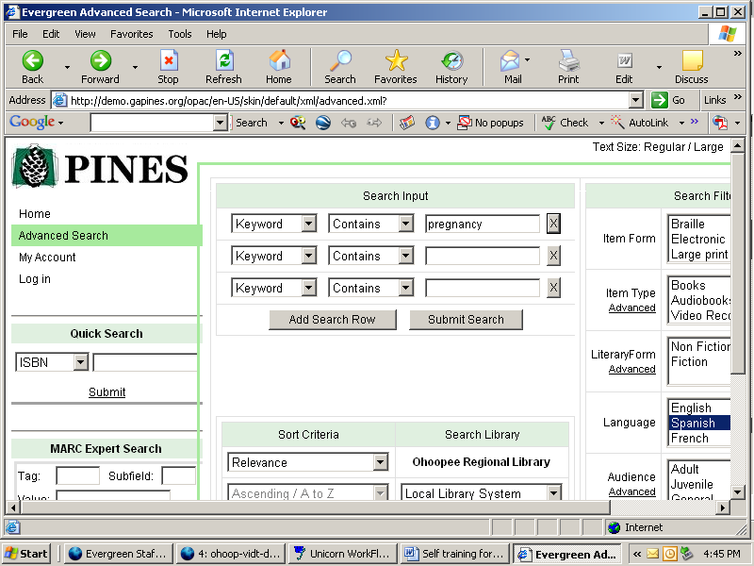

Click on Submit Search and the results would look like this:

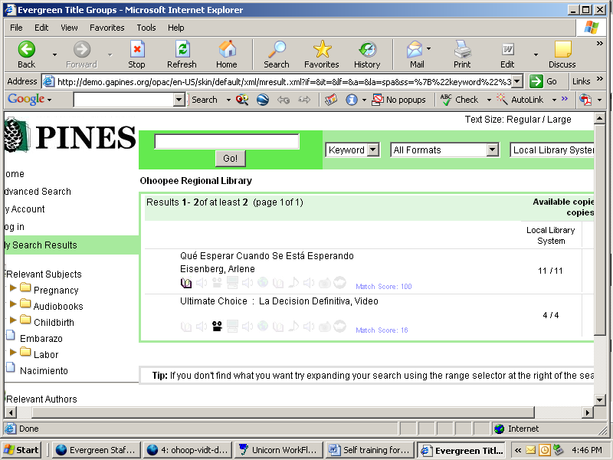

6. Using the advanced search features and the basic retrieval skills learned in the earlier lessons, answer the questions:
a. Does any library in PINES have a nonfiction book about oceans in Spanish?
b. Does any library in PINES have a fiction book in Spanish for juveniles about oceans?
c. Who owns it and is it available to place a HOLD on it?

7. Clear your search by going HOME, on the Evergreen screen. Than, enter Advanced Search again. Look at the Search Filters.

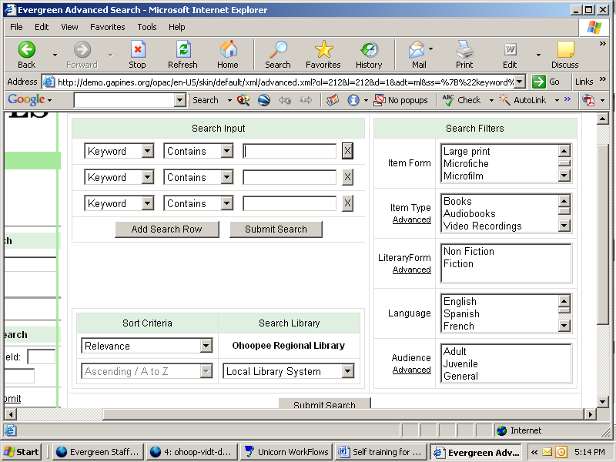

Notice that the filters have scrolling menus to help you search. Look at Item Type, Literary Form, and Audience.
Choose Literary Form. Click on Advanced. Notice the additional formats to search. Click on Advanced on the other filters. Look at the expansion.

8. Does the Montgomery County Library have the book whose ISBN number is 0970910517 ?

**Other features will be discussed during training. Please take the time to review these four lessons and make sure you are familiar with the gapines catalog.

ANSWERS

1. a. 44 b. No c. 4. d. No e. Error in query NEAR "AND"

2. a. 2 b. Yes, that title only c. 3 d. Yes, that title only e. Get 3 metarecords for the title.

3. The current catalog uses a special type of searching called Boolean – it reads the word “not” as meaning, “don’t use the next word.” So for A and B, it did not search that whole title – only certain of the words. This type of searching also does not recognize common words unless they are in “quotations”. So the word And in title C was kicked out. The new Evergreen catalog uses a simple all word search format.

4. a. Quick search; MARC Expert Search; Search Input; Search Filters; Sort Criteria; Search Library
b. They are boxed in green.

6. The search screen for question a. would look like this:
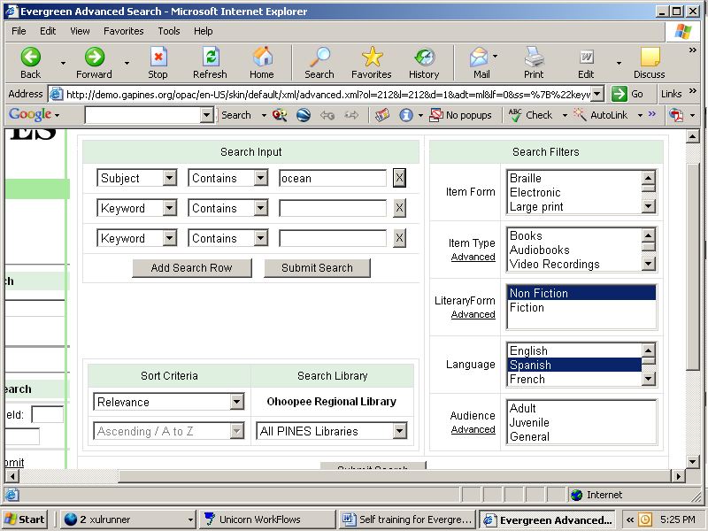

The search screen for question b. would look like this:
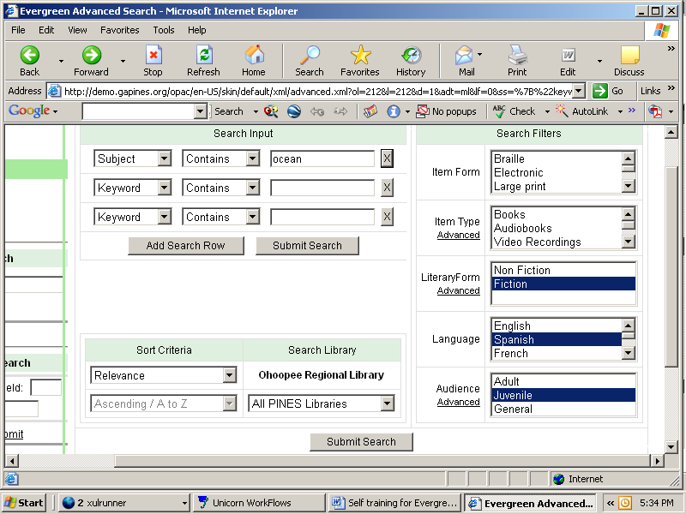

The results screen would look like this:
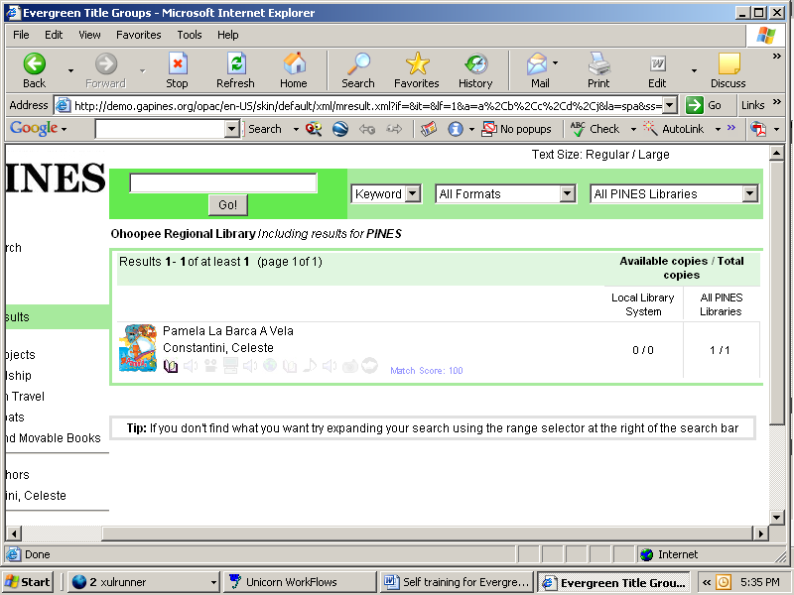

Then click on the title/view copy information for all libraries/details and the answer is:
Southwest Georgia Regional Library/Gilbert Gragg Memorial Library/ 1 copy/available
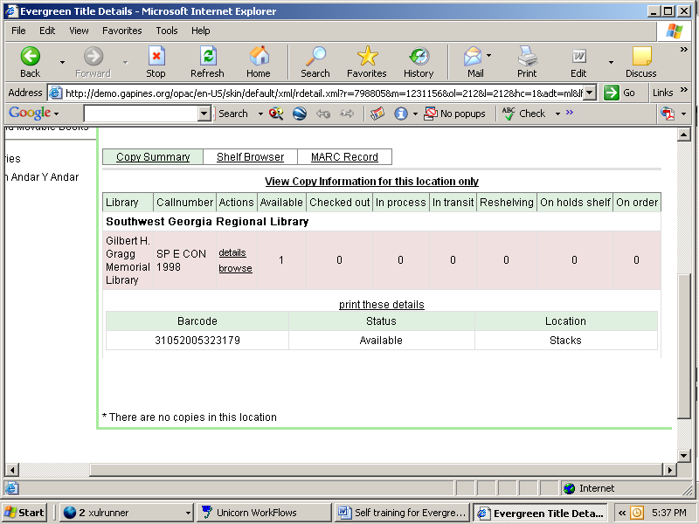

8. Yumion Goes To The City by Rhonda Kight. Yes.

