The Acquisitions Module
Evergreen Release 2.0.0

License

This manual is licensed under the Creative Commons, Attribution-Share-Alike license. This document was created by Equinox Software, Inc. with funding provided by Georgia Public Library Service. Any reproductions or adaptations must attribute original creation of this work to Equinox Software, Inc. and Georgia Public Library Service. Any reproductions or adaptations must be distributed under the same or a similar license.

Abstract

This documentation is intended for users who will be performing front line processes in the acquisitions module. Documented functions include creating selection lists, creating and activating purchase orders, and receiving, invoicing, and claiming items. Administrative functions are documented in Administration Functions in the Acquisitions Module.

This document is intended for first time users of the Acquisitions module as well as those who are familiar with the module and need only a reference guide. The contents of this document are alphabetized by topic.

Table of Contents

1. Brief Records
  - Add brief records to a selection list
  - Add brief records to purchase orders
2. Cancel/Suspend acquisitions
2.1 Cancel/Suspend copies
2.2 Cancel/Suspend line items
2.3 Cancel/Suspend purchase orders
3. Claim items
3.1 Apply a claim policy
3.2 Change a claim policy
3.3 Claim an item
3.4 Produce a list of claim-ready items
4. Export Single Attribute List
5. Funds
5.1 Apply funds to individual copies
5.2 Apply funds to copies via batch updates to line items
6. Invoice acquisitions
6.1 Create a blanket invoice
6.2 Create an invoice for a line item
6.3 Create an invoice for a purchase order
6.4 Link an existing invoice to a purchase order
6.5 View an invoice
7. Line Items
7.1 Add alerts to a line item
7.2 Add copies to a line item
7.3 Add notes to a line item
7.4 Cancel a line item
7.5 Line item actions
7.5.1 Apply claim policy
7.5.2 Claims
7.5.3 Holdings maintenance
7.5.4 Link to invoice
7.5.5 Mark received
7.5.6 New invoice
7.5.7 Un-receive
7.5.8 Update barcodes
7.5.9 View history
7.5.10 View invoice
7.6 Line item worksheet
7.7 Link line items to the catalog
8. Load Bib Records and Items into the Catalog
9. Load Catalog Record IDs
10. Load MARC order records
11. MARC Federated Search
12. Patron Requests
13. Purchase Orders
  - Activate a purchase order
  - Add brief records to a purchase order
  - Add charges, taxes, fees, or discounts to a purchase order
  - Add notes to a purchase order
  - Cancel/suspend a purchase order
  - Create a purchase order
  - Mark ready for order
  - Name a purchase order
  - Print purchase orders
  - Receive a purchase order
  - Split order by line items
  - View on order purchase orders
  - View EDI messages on a purchase order
  - View purchase order history
14. Receive/Un-Receive acquisitions
14.1 Receive/un-receive copies
  - Receive/un-receive line items
  - Receive/un-receive purchase orders
15. Search the acquisitions module
16. Selection Lists
  - Add items to a selection list
  - Clone selection lists
  - Convert selection list to purchase order
  - Create a selection list
  - Delete selection lists
  - Mark ready for selector
  - Merge selection lists
17. View/Place Orders

1. Brief Records

Brief records are short bibliographic records with minimal information that are often used as placeholder records until items are received. Brief records can be added to selection lists or purchase orders and can be imported into the catalog. You can add brief records to new or existing selection lists. You can add brief records to new, pending or on-order purchase orders.

1.1 Add brief records to a selection list

- Click Acquisitions → New Brief Record. You can also add brief records to an existing selection list by clicking the Actions menu on the selection list and choosing Add Brief Record.

- Choose a selection list from the drop down menu, or enter the name of a new selection list.

- Enter bibliographic information in the desired fields.

- Click Save Record.

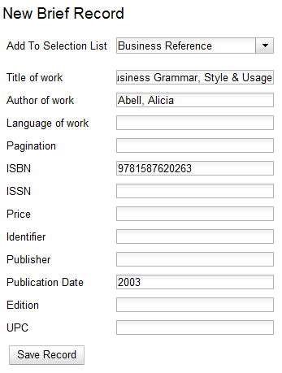

1.2 Add brief records to purchase orders

You can add brief records to new or existing purchase orders.

- Open or create a purchase order. See section 13 for more information.

- Click Add Brief Record.

- Enter bibliographic information in the desired fields. Notice that the record is added to the purchase order that you just created.

- Click Save Record.

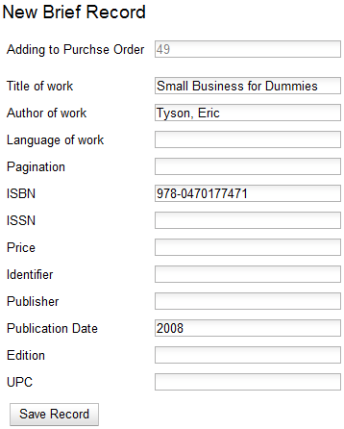

2. Cancel/suspend acquisitions

You can cancel entire purchase orders, line items on the purchase orders, and individual copies that are attached to a line item. You can also use cancel reasons to suspend purchase orders, line items, and copies. For example, a cancel reason such as Delayed Publication, would indicate that the item will be purchased when the item is published. The purchase is, in effect, suspended rather than cancelled, but the state of the purchase order, line item, or copy would still become cancelled.

2.1 Cancel/suspend copies

You can cancel or suspend line items that are in a state of on order or pending order.

- Select the Copies link.

- Click the Cancel link adjacent to the copy that you wish to cancel.

- Select a cancel reason from the drop down menu that appears, and click Cancel copy.
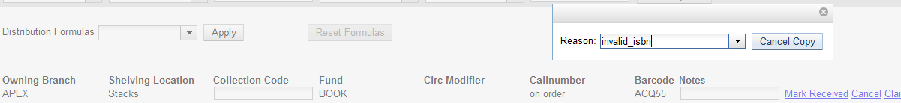

2.2 Cancel/suspend line items

You can cancel or suspend line items that are in a state of on order or pending order.

- Check the boxes of the line items that you wish to cancel.

- Click Actions →Cancel Selected Lineitems.

- Select a cancel reason from the drop down menu. Choose the cancel reason, and click Cancel Line Items. The status of the line item is now cancelled.

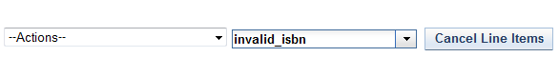

2.3 Cancel/suspend purchase orders

- Notice the Cancel column in the top half of the purchase order.

- Click the drop down arrow adjacent to Cancel order, and select a reason for cancelling the order.

- Click Cancel order. The state of the purchase order is cancelled.

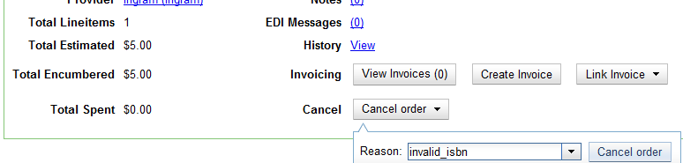

3. Claim items

Manual claiming of items can be accomplished in multiple ways, but electronic claiming is not available in the 2.0 release.

You can apply claim policies to line items or individual copies. You also can use the default claim policy associated with your provider to claim items.

3.1 Apply a claim policy

You can apply a claim policy to an item in one of two ways: apply a claim policy to a line item when the item is created on the selection list or purchase order, or use the default claim policy associated with the provider on the purchase order. The default claim policy for a provider is established when the provider is created and will be used for claiming if no claim policy has been applied.

- Open a selection list or purchase order. See section 13 for more information.

- Click the Actions drop down menu on the line item.

- Click Apply Claim Policy.

- A drop down menu of claim policies will appear. Choose a claim policy to apply to the line item. The claim policy will be applied to all items that have not been received or cancelled.

- Click Save.

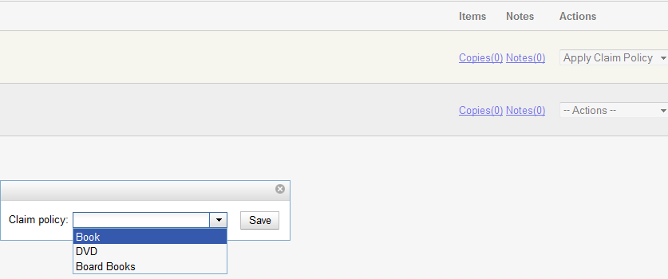

3.2 Change a claim policy

You can manually change a claim policy that has been applied to a line item.

- Open a selection list or purchase order.

- Click the Actions drop down menu on the line item.

- Click Change Claim Policy.

- A drop down menu of claim policies will appear. Choose a claim policy to apply to the line item.

- Click Save.

3.3 Claim an item

You can manually claim items at any time after the item has been ordered.

- Open a purchase order.

- Click the Actions drop down menu on the line item.

- Click Claims. The number of existing claims appears in parentheses.

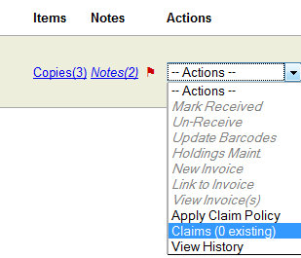

- A drop down menu of items to be claimed and possible claim actions appears. Check the boxes adjacent to the item that you want to claim and the action that you will take. You can claim items that have not been received or cancelled.

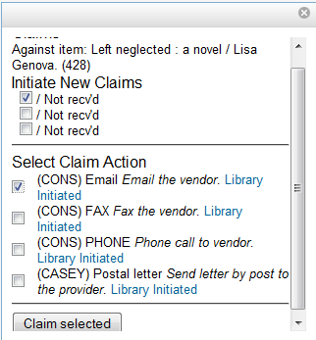

5. Click Claim Selected.

6. Select a claim type from the drop down menu. Entering a note is optional.

7. Click Claim.

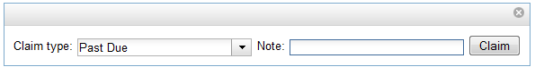

8. The number of existing claims on the line item updates, and a claim voucher appears. The voucher can be printed and mailed to the vendor to initiate the claim.

3.4 Produce a list of claim-ready items

If an item has not been received and meets the conditions for claiming according to the item’s claim policy, then the item will be eligible for claiming. Evergreen can produce a list of items, by ordering branch, which is ready to be claimed. You can use this list to manually claim items from your provider.

- Click Acquisitions →Claim-Ready Items.

- Choose a branch from the drop down menu to claim items that were ordered by this branch.

- Any items that meet the conditions for claiming will appear.

4. Check the box adjacent to the line items that you wish to claim. Click Claim selected items.

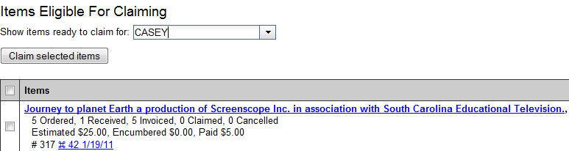

6. Select a claim type from the drop down menu. Entering a note is optional.

7. Click Claim.

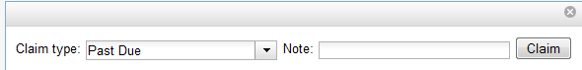

4. Export Single Attribute List

You can export ISBNs, ISSNs, or UPCs as a file from the list of line item(s). A list of ISBNs, for example, could be uploaded to vendor websites when placing orders.

- From a selection list or purchase order, check the boxes of the line items with attributes that you wish to export.

- Click Actions → Export Single Attribute List.

- Choose the line item attribute that you would like to export from the drop down list of attributes.

- Click Export List.

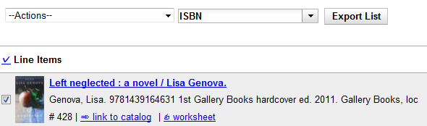

- Save the file to your computer.

- Open the file. Choose a program to open the file. The following is an example of an ISBN in a spreadsheet.

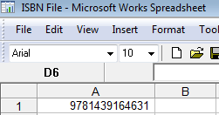

5. Funds

You can apply a single fund or multiple funds to copies on a selection list or purchase order. You can change the fund that has been applied to an item at any time on a selection list. You can change the fund that has been applied to an item on a purchase order if the purchase order has not yet been activated.

Funds can be applied to items from the Copies link that is located on a line item. Funds can also be applied to copies by batch updating line items and their attendant copies.

5.1 Apply funds to individual copies

- Click the Copies link on the line item.

- To apply a fund to an individual item, click the drop down arrow in the Fund field.

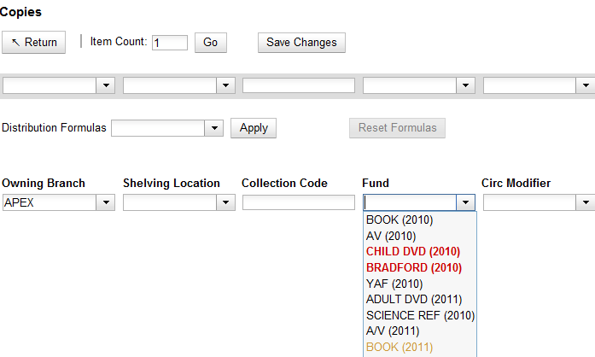

A yellow fund name indicates that the balance in the fund has dropped to the warning percent that was entered in the admin module. A red fund name indicates that the balance in the fund has dropped to the stop percent that was entered in the admin module. Funds that have been closed out will no longer appear on the drop down list.
NOTE

- To apply a fund to multiple items, see section 7 for more information.
5.2 Apply funds to copies via batch updates to line items

You can apply funds to all copies on a line item(s) from the Actions menu on the selection list or the purchase order.

- Check the boxes of the line items with copies to which you would like to apply funds.

- Click Actions →Apply Funds to Selected Items.

- Select the fund that you wish to apply to the copies.

- Click Submit.

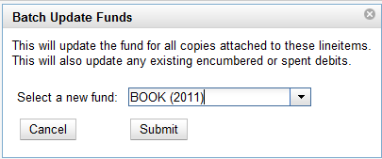

- Invoice acquisitions

You can create invoices for purchase orders, individual line items, and blanket purchases. You can also link existing invoices to purchase orders. In 2.0, all invoicing is manual.

You can invoice items before you receive the items if desired. You can also reopen closed invoices, and you can print all invoices.

6.1 Create a blanket invoice

You can create a blanket invoice for purchases that are not attached to a purchase order.

- Click Acquisitions → Create invoice.

- Enter the invoice information in the top half of the screen. See section 6 .1 for more information.

- Select a charge type from the drop down menu.

- Select a fund from the drop down menu.

- Enter a Title/Description of the resource.

- Enter the amount that you were billed.

- Enter the amount that you paid.

- Save the invoice. See section 6.1 for more information.

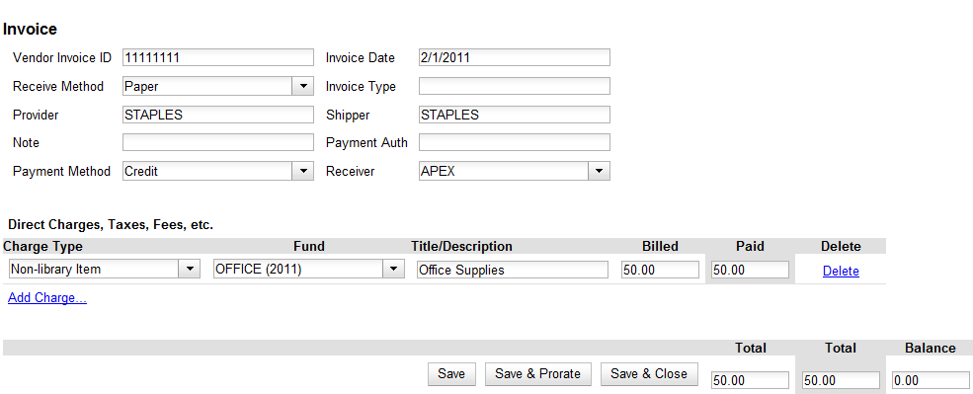

6.2 Create an invoice for a line item

See section 7.5.6 for details.

6.3 Create an invoice for a purchase order

You can create an invoice for all of the line items on a purchase order. The only fields that are required to save the invoice are the Vendor Invoice ID and the number of items invoiced, billed, and paid for each line item. With the exception of fields with drop down menus, no limitations on the data that you enter exist.

- Open a purchase order.

- Click Create Invoice.

- Enter a Vendor Invoice ID. This number may be listed on the paper invoice sent from your vendor.

- Choose a Receive Method from the drop down menu.

Only paper invoicing is available in the 2.0 release. Electronic invoicing may be available in future releases.
NOTE

- The Provider is generated from the purchase order and is entered by default.

- Enter a note.

- Select a payment method from the drop down menu.

- The Invoice Date is entered by default as the date that you create the invoice. You can change the date by clicking in the field. A calendar drops down.

- Enter an Invoice Type.

- The Shipper defaults to the provider that was entered in the purchase order.

- Enter a Payment Authorization.

- The Receiver defaults to the branch at which your workstation is registered. You can change the receiver by selecting an org unit from the drop down menu.

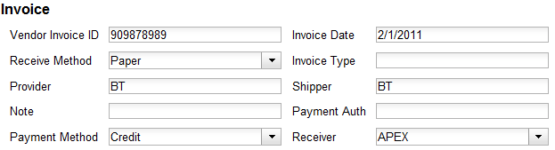

The bibliographic line items are listed in the next section of the invoice. Along with the title and author of the line items is a summary of copies ordered, received, invoiced, claimed, and cancelled. You can also view the amounts estimated, encumbered, and paid for each line item. Finally, each line item has a line item ID and links to the selection list (if used) and the purchase order.

- Enter the number of items that were invoiced, the amount that the organization was billed, and the amount that the organization paid.

- You have the option to add charge types if applicable. Charge types are additional charges that can be selected from the drop down menu. Common charge types include taxes and handling fees.

- You have three options for saving an invoice. You can click Save, which saves the changes that you have made, but keeps the invoice open. You can click Save and Prorate, which enables you to save the invoice and prorate any additional charges, such as taxes, across funds, if multiple funds have been used to pay the invoice. You also can click Save and Close. Choose this option when you have completed the invoice.

NOTE
You can re-open a closed invoice by clicking the link, Re-open invoice. This link appears at the bottom of a closed invoice.

6.4 Link an existing invoice to a purchase order

You can use the link invoice feature to link an existing invoice to a purchase order. For example, an invoice is received for a shipment with items on purchase order #1 and purchase order #2. When the invoice arrives, purchase order #1 is retrieved, and the invoice is created. To receive the items on purchase order #2, simply link the invoice to the purchase order. You do not need to recreate it.

- Open a purchase order.

- Click Link Invoice.

- Enter the Invoice # and the Provider of the invoice to which you wish to link.

- Click Link.

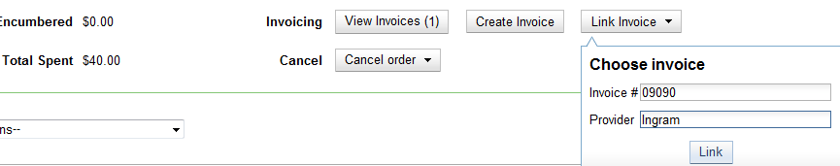

6.5 View an invoice

You can view an invoice in one of four ways: view open invoices; view invoices on a purchase order; view invoices by searching specific invoice fields; view invoices attached to a line item.

- To view open invoices, click Acquisitions → Open invoices. This opens the Acquisitions Search screen. The default fields search for open invoices. Click Search.

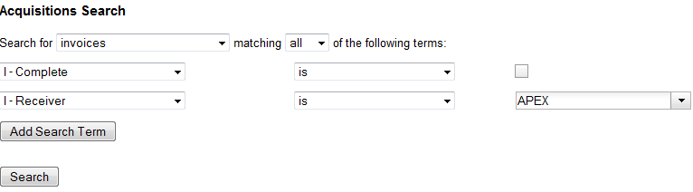

- To view invoices on a purchase order, open a purchase order, and click the View Invoices link. The number in parentheses indicates the number of invoices that are attached to the purchase order.

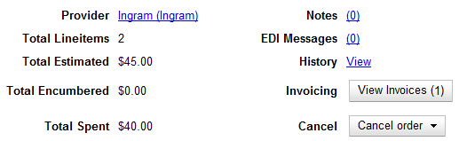

- To view invoices by searching specific invoice fields, see section 15.

- To view invoices for a line item, see section 7.5.10.

7. Line Items

Line items represent bibliographic records on a selection list or purchase order. One line item corresponds to one bibliographic record. Line items contain attributes, which are characteristics of the bibliographic record, such as ISBNs or Title. Line items also contain copy information, price information, and notes and alerts.

  - Add alerts to a line item

Alerts are pop up messages that appear when an item is received. Alerts can be printed on the line item worksheet.

- Click the Notes link on the line item.

- Click the New Alert drop down button.

- Choose an alert code from the drop down menu.

- Add additional comments if desired.

- Click Create. The alert will display on the screen.

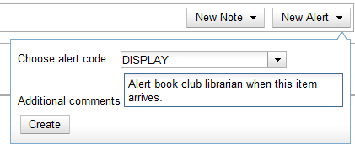

- Click Return to return to the line item. When you return to the line item, a flag will appear to indicate that an alert is on the line item.

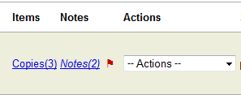

  - Add copies to a line item

Use the Copies link to add copy information to a line item. You can add copies to line items on a selection list or a purchase order.

- Click the Copies link on a line item.

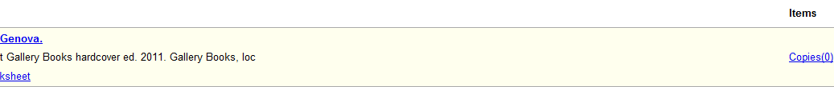

- Enter the number of items that you want to order in Item Count, and click Go. The number of items that you want to order will display below.

- If desired, apply a Distribution Formula from the drop down list. Distribution formulas tell the ILS how many copies should be distributed to each location.

- The owning branch and shelving location populate with entries from the distribution formula. Click Apply.

- Look back at the top gray row of text boxes above the distribution formula. Each text box in this row corresponds to the columns below. Changes made here will be applied to all copies below. Click Batch Update.

- Click Save Changes.

- Click Return to return to the selection list or purchase order.

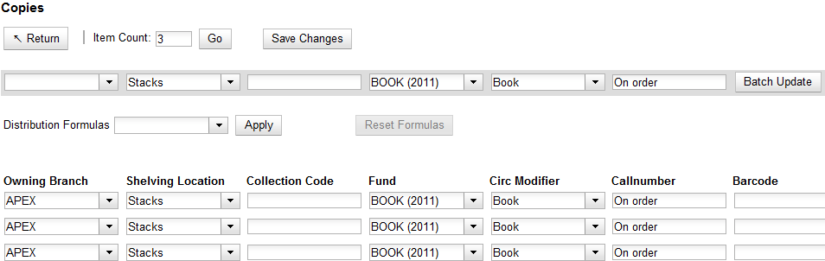

- Add the item’s price to the line item in the Estimated Price field.

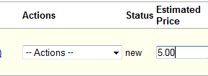

7.3 Add notes to a line item

Notes on line items can include any additional information that you want to add to the line item. Notes can be internal or can be made available to providers. Notes appear in a pop up box when an item is received. Notes can be printed on line item worksheets, which can be printed and placed in books for processing.

- Click the Notes link on the line item.

- Click the New Note drop down button.

- Enter a note.

- You have the option to make this note available to your provider. Click the check box adjacent to Note is vendor-public.

- Click Create. The note will appear on the screen.

- Click Return to return to the line item. When you return to the line item, a number in parentheses adjacent to notes indicates how many notes are attached to the item.

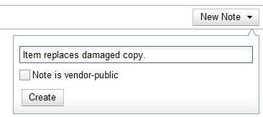

7.4 Cancel a line item

For more information, see section 2.

  - Line item actions

7.5.1 Apply claim policy

See section 3.1 for more information.

7.5.2 Claims

See section 3.3 for more information.

7.5.3 Holdings maintenance

After an item has been received, click Actions → Holdings Maintenance to edit holdings. The Holdings Maintenance screen opens in a new tab.

7.5.4 Link to invoice

Use the Link to invoice menu item to link the line item to an invoice that already exists in the ILS.

1. Click Actions → Link to Invoice.

2. A pop up box appears. Enter an invoice number.

3. Enter a provider. The field will auto-complete.

4. Click Link.

7.5.5 Mark received

See section 14.2 for more information.

7.5.6 New invoice

See section 6 for more information.

7.5.7 Un-receive

See section 14.2 for more information.

7.5.8 Update barcodes

After an item has been received, click Actions → Update Barcodes to edit holdings. The Volume and Copy Creator screen opens in a new tab.

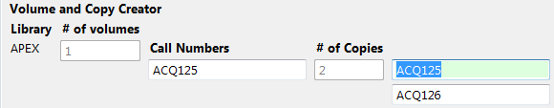

7.5.9 View history

Click Actions → View history to view the changes that have occurred in the life of the line item.

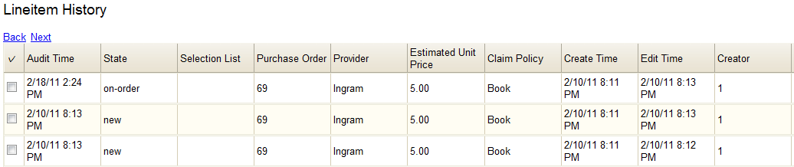

7.5.10 View invoice

Click Actions → View invoice to view any invoices that are attached to the line item.

7.6 Line Item Worksheet

The Line Item Worksheet was designed to be a printable sheet that contains details about the line item, including alerts and notes, and distribution of the copies. This worksheet could placed in a book that is sent to cataloging or processing.

- From a selection list or purchase order, click the worksheet link on the line item.

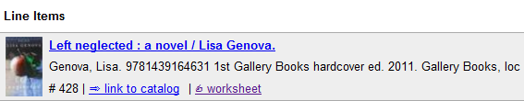

- The line item worksheet appears.

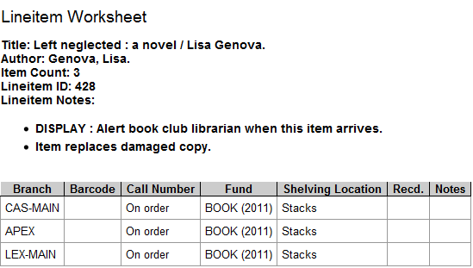

- To print the worksheet, click the Print Page link in the top right corner.

  - Link line items to the catalog

You can link a MARC record or brief record on a selection list to the corresponding MARC record in the catalog. This may be useful for librarians who have a brief MARC record in their catalog and want to import a better record that is attached to their selection list. No collision detection exists when importing an item into the selection list or catalog, so the link to catalog option enables you to search for a matching record and link to it from the selection list or purchase order. When you import the record from the purchase order, the record will overlay the linked record in the catalog.

1. From the line item, click Link to catalog.

2. In the text box that pops up, search terms, such as ISBN and title, are entered by default.

3. Click Search.

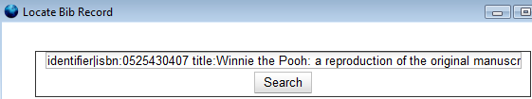

4. Result(s) appear. Click the link to View MARC, or Select the record to link it to the record on the selection list or purchase order.

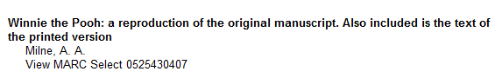

5. The screen will reload, and the line item displays with a catalog link. The records are linked.

8. Load Bib Records and Items Into the Catalog

You can load bib records and items into the catalog at three different locations in the acquisitions module.

- You can import bib records and items (if holdings information is attached) when you upload MARC order records. Click Acquisitions → Load MARC Order Records and check the box adjacent to Load Bibs and Items into the ILS.

- You can import bib records and items into the catalog when you create a purchase order from a selection list. From the selection list, click Actions → Create Purchase Order. Check the box adjacent to Load Bibs and Items into the ILS to import the records into the catalog.

- You can import bib records and items into the catalog from a purchase order by clicking Actions → Load Bibs and Items.

If you have not loaded bib records and items into the catalog before you activate a purchase order, then the ILS will automatically import the bib records and items into the catalog when you activate the purchase order.
NOTE

9. Load Catalog Record IDs

The Load Catalog Record IDs function enables you to create line items from a list of catalog records whose record IDs are saved in a CSV file.

This would be useful if you want to batch order copies of items that your organization already owns. For example, you run a copy/hold ratio report to identify how many copies you have available compared to the number of holds that are on your Hot Fiction display. You decide that you want to order an extra copy of six titles. Your copy/hold ratio report includes the record ID of each title. You can save the record IDs into a CSV file, upload the file into the ILS, and create a purchase order for the items.

1. Create a CSV file with the record ID of each catalog record in the first column of the spreadsheet. You can create this CSV file from a spreadsheet generated by a report, as suggested in the aforementioned example. You can also copy and paste record IDs from the catalog record into the CSV file.

Record IDs are auto-generated digits associated with each record. They are found in the Record Summary that appears at the top of each record.
NOTE

2. Save the CSV file to your computer.

3. Click Acquisitions → Load Catalog Record IDs.

4. Click Load More Terms.

5. The screen will display the number of terms (record IDs) that have been loaded.

6. Click Retrieve Records. The records will appear as line items to which you can add copies, notes, and pricing information. Use the Actions menu to save these items to a selection list or purchase order.

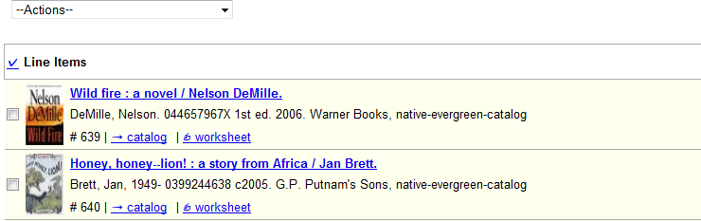

10. Load MARC Order Records

The Load MARC Order Records screen enables you to upload MARC records that have been saved on your computer into the ILS. You can add the records to a selection list and/or to a purchase order. You can both create and activate purchase orders in one step from this interface. Also, from this interface, you can load bibs and items into the catalog.

- Click Acquisitions → Load MARC Order Records

- If you want to upload the MARC records to a new purchase order, then click the check box adjacent to Create Purchase Order.

- If you want to activate the purchase order at the time of creation, then click the check box adjacent to Activate Purchase Order.

- If you want to load bibs and items into the catalog, then click the check box adjacent to Load Bibs and Items into the ILS.

- Enter the name of the Provider. The text will auto-complete.

- Select an org unit from the drop down menu. The context org unit is the org unit that "owns" the bib record. You should select a physical location rather than a political or administrative org unit as the context org unit. For example, the Smith County Library System is funding purchase of a copy of Gone with the Wind. The system owns the bib record, but it cannot receive the physical item. The acquisitions librarian will choose a physical branch of that system, a processing center or an individual branch, to receive the item.

- If you want to upload the records to a selection list, you can select a list from the drop down menu, or type in the name of the selection list that you want to create.

- Click Browse to search for the file of bibliographic records.

- Click Upload.

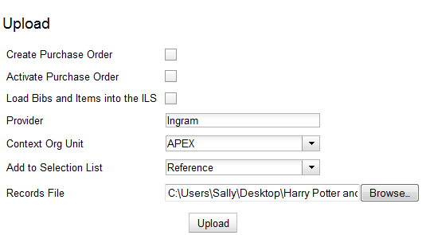

- A summary of the items that have been processed will appear.

- Click the links that appear to view the purchase order or the selection list.

- MARC Federated Search

The MARC Federated Search enables you to import bibliographic records into a selection list or purchase order from a Z39.50 source.

- Click Acquisitions → MARC Federated Search.

- Check the boxes of Z39.50 services that you want to search. Your local Evergreen Catalog is checked by default. Click Submit.

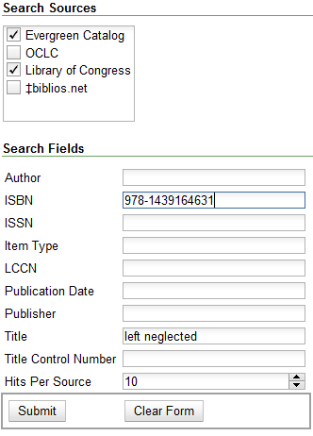

- A list of results will appear. Click the Copies link to add copy information to the line item. See section 7 for more information.

- Click the Notes link to add notes or line item alerts to the line item. See section 7 for more information.

- Enter a price in the Estimated Price field.

- You can save the line item(s) to a selection list by checking the box on the line item and clicking Actions →Save Items to Selection List. You can also create a purchase order from the line item(s) by checking the box on the line item and clicking Actions → Create Purchase Order.

- Patron Requests

The patron requests interface will allow you to view requests that patrons make via the OPAC. The functionality for OPAC requests is not currently available in the native Evergreen interface, so the screen remains blank in 2.0.

- Purchase Orders

You can create a purchase order from a selection list, a batch upload of MARC order records, the View/Place Orders link in the catalog, or results from a MARC Federated Search. For more information on creating purchase orders using these methods, see sections 16, 10, 17, and 11.

You can also create blanket purchase orders to which you can add brief records or generic charges and fees.

13.1 Activate a purchase order

Before you can active a purchase order, the following criteria must be met:

- The field, Activate Order?, is located in the top half of the purchase order. The answer adjacent to this field must be Yes.

- Each line item must contain an estimated price. If the Activate Order? field in the top half of the purchase order reads, No: The lineitem has no price (ACQ_LINEITEM_NO_PRICE), then simply enter a price in the estimated price field, tab out of the field, and click Reload.

When the above criteria have been met, proceed with the following:

- Look at the Activate Order? field in the top half of the purchase order. Click the hyperlinked Activate Order. When you activate the order, the bibliographic records and copies will be imported into the catalog, and the funds associated with the purchases will be encumbered.

13.2 Add brief records to a purchase order

To add brief records to a purchase order, see section 2.2 for more information. You can add brief records to new or existing purchase orders.

13.3 Add charges, taxes, fees, or discounts to a purchase order

You can add charges, taxes, fees, or discounts to a purchase order. These additional charges will be reflected in the amounts that are estimated and encumbered on the purchase order.

- Open or create a purchase order.

- Click New charge.

- Select a charge type from the drop down menu.

- Select a fund from the drop down menu.

- Enter a Title/Description, Author, and Note if applicable.

- Enter an estimated cost.

- Add another new charge, or click Save New Charges.

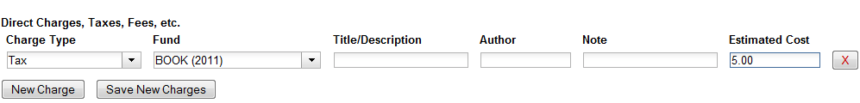

Discounts are not consistently supported in the 2.0 release.
NOTE

13.4 Add notes to a purchase order

You can add notes to each purchase order. These can be viewed by staff and/or by the provider. By default, notes are only visible to staff.

- Open a purchase order.

- In the top half of the purchase order, you see a Notes field. The number of notes that are attached to the purchase order is hyperlinked in parentheses next to the Notes field.

- Click the hyperlinked number.

- Click New Note.

- Enter the note. If you wish to make it available to the provider, click the check box adjacent to Note is vendor-public.

- Click Create.

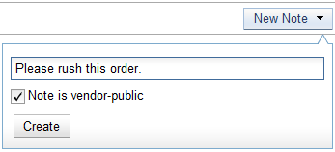

13.5 Cancel/Suspend a purchase order

To cancel or suspend a purchase order, see section 2.1.

13.6 Create a purchase order

- Click Acquisitions → Create Purchase Order.

- A pop-up box appears. Select an owning library from the drop down menu.

- Enter a provider in the box. The text will auto complete.

- Check the box adjacent to Prepayment Required.

- Click Save.

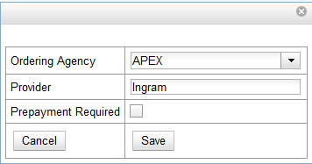

- The purchase order has been created. You can now create a new charge type or add a brief record.

The Total Estimated is the sum of the prices. The Total Encumbered is the total estimated that is encumbered when the purchase order is activated. The Total Spent column automatically updates when the items are invoiced.
NOTE

13.7 Mark ready for order

After an item has been added to a selection list or purchase order, you can mark it ready for order. This step is optional but may be useful to individual workflows.

- If you want to mark part of a selection list ready for selector, then you can check the box(es) of the line item(s) that you wish to mark ready for selector. If you want to mark the entire list ready for selector, then skip to step 2.

- Click Actions → Mark Ready for Order.

- A pop up box will appear. Choose to mark the selected line items or all line items.

- Click Go.

- The screen will refresh. The line item will be highlighted gray, and the status will change to order-ready.

13.8 Name a purchase order

A new purchase order is given the purchase order ID as a default name. However, you can change that name to any grouping of letters or numbers. You can reuse purchase order names

as long as a name is never used twice in the same year.

- Open or create a purchase order.

- The Name of the purchase order is in the top left column of the purchase order. The hyperlinked number is an internal ID number that Evergreen has assigned.

- To change this number, click on the hyperlinked ID.

- Enter a new purchase order number in the pop up box.

- Click OK.

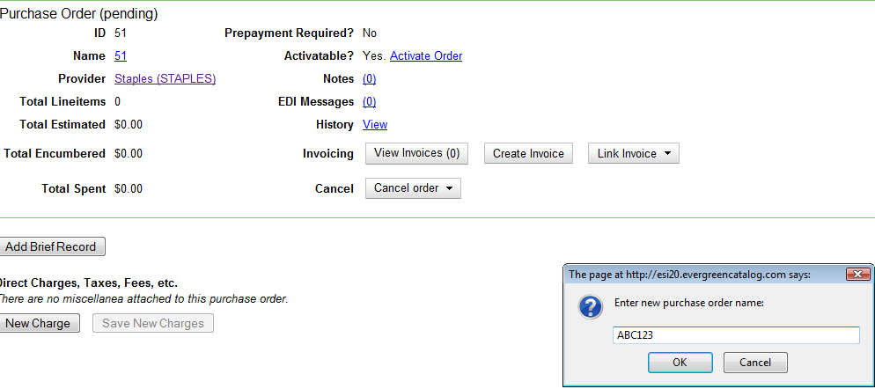

13.9 Print purchase orders

You can print a purchase order from the purchase order screen. If you add a note to a line item, the note will only appear in the Notes column on the printed purchase order if you make the note vendor-public. Currently, no notes appear in the Notes to the Vendor section of the printed purchase order.

- Open a purchase order.

- Click Actions → Print Purchase Order.

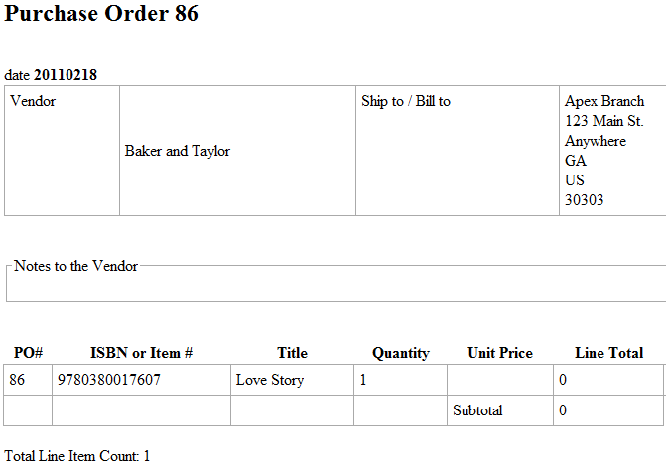

13.10 Receive a purchase order

See section 14.1 for more information on receiving a purchase order.

13.11 Split order by line items

You can create a purchase order with multiple line items, and then split the purchase order so that each line item is on separate purchase orders.

When a purchase order is in the status of pending, a link to split order by Lineitems appears in the bottom left corner of the top half of the screen.

- Click Split Order by Lineitems.

- A pop up box will confirm that you want to split the purchase order. Click OK to continue.

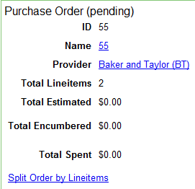

- The items will display by default as a virtual combined purchase order. Future enhancements will allow you to activate the purchase order for each item from this screen.

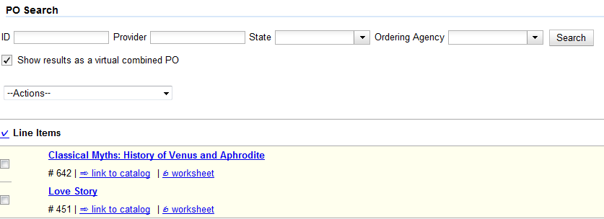

13.12 View On-Order Purchase Orders

You can view a list of on-order purchase orders by clicking Acquisitions –> Purchase Orders. The ordering agency defaults to the branch at which your workstation is registered. The state of the purchase order defaults to on-order.

You can add more search terms by clicking Add Search Term. Search terms are ANDed together. Click Search to begin your search.

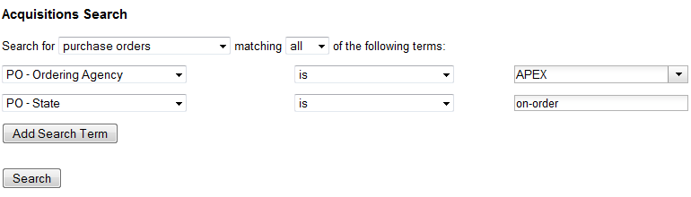

If you want to expand or change your search of purchase orders, you can choose other criteria from the drop down menus. See section 15 for more information.

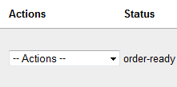

13.13 View EDI messages on a purchase order

You can view electronic messages from your vendor about a specific purchase order.

- Open a purchase order.

- In the top half of the purchase order, you see an EDI Messages field. The number of messages that are attached to the purchase order is hyperlinked in parentheses next to the EDI Messages field.

- Click the hyperlinked number to view the messages.

13.14 View Purchase Order History

In the top half of the purchase order, you can view the history of the purchase order. Click the View link in the History field.

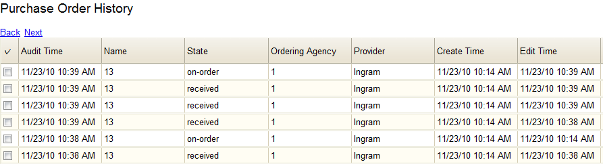

- Receiving

You can receive and un-receive entire purchase orders, line items, and individual copies. You can receive items before or after you invoice items.

14.1 Receive/un-receive copies

- To receive copies, click the Copies link on the line item, and click the Mark Received link adjacent to each copy.

- To un-receive copies, click the Copies link on the line item, and click the Un-Receive link adjacent to each copy.

14.2 Receive/un-receive line items

1. To receive a line item, click the Actions → Mark Received link on the line item.

1. To un-receive a line item, click the Actions → Un-receive link on the line item.

14.3 Receive/un-receive purchase orders

- To receive a purchase order, click Actions →Mark Purchase Order as Received. The purchase order will have a state of received.

- To un-receive a purchase order, click Actions →Un-Receive Purchase Order. The purchase will have a state of on order.

- Searching

In the acquisitions module, you can search line items, line items and catalog records, selection lists, purchase orders, and invoices. To access the searching interface, click Acquisitions → General Search.

Users may wish to begin their acquisitions process by searching line items and catalog records. This ensures that they do not purchase an item that the library already owns or is on another selection list or purchase order.
NOTE

- Choose the object that you would like to search from the drop down menu.

- Next, refine your search by choosing the specific fields that you would like to search. Click Add Search Term to add more fields. Search terms are ANDed together. Click the red X at the end of each row to delete search terms. Some search terms will be disabled depending on your choice of items to search.

- After you have added search term(s), click Search or click the Enter key. A list of results appears.

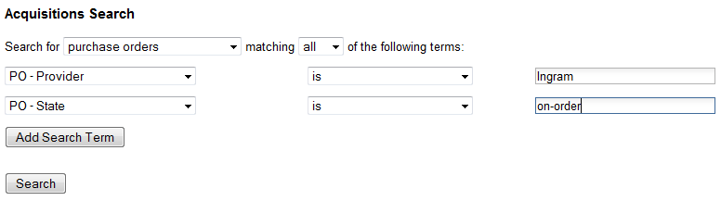

4. If you want to edit your search, click the Reveal Search button in the top right corner of the results screen to display your search.

- Selection Lists

Selection lists allow you to create, manage, and save lists of items that you may want to purchase. To view your selection list, click Acquisitions → My Selection Lists. Use the general search to view selection lists created by other users.

  - Create a selection list

Selection lists can be created in four areas within the module. Selection lists can be created when you Add Brief Records, Upload MARC Order Records, or find records through the MARC Federated Search. In each of these interfaces, you will find the Add to Selection List field. Enter the name of the selection list that you want to create in that field.

Selection lists can also be created through the My Selection Lists interface:

- Click Acquisitions → My Selection Lists.

- Click the New Selection List drop down arrow.

- Enter the name of the selection list in the box that appears.

- Click Create.

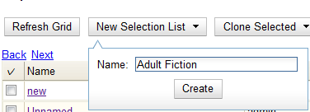

  - Add items to a selection list

You can add items to a selection list in one of three ways: add a brief record (section 2); upload MARC order records (section 10); add records through a federated search (section 11); or use the View/Place Orders menu item in the catalog (section 17). See the sections listed in parentheses for more information on each of these methods.

  - Clone selection lists

Cloning selection lists enables you to copy one selection list into a new selection list. You can maintain both copies of the list, or you can delete the previous list.

- Click Acquisitions → My Selection Lists.

- Check the box adjacent to the list that you want to clone.

- Click Clone Selected.

- Enter a name into the box that appears, and click Clone.

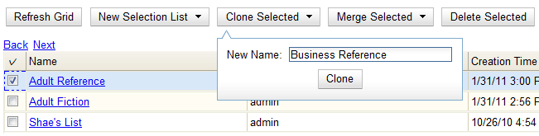

  - Merge selection lists

You can merge two or more selection lists into one selection list.

- Click Acquisitions → My Selection Lists.

- Check the boxes adjacent to the selection lists that you want to merge, and click Merge Selected.

- Choose the Lead Selection List from the drop down menu. This is the list to which the items on the other list(s) will be transferred.

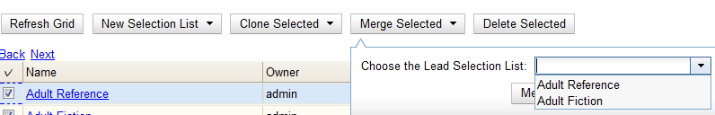

- Click Merge.

  - Delete selection lists

You can delete selection lists that you do not want to save. You will not be able to retrieve these items through the General Search after you have deleted the list. You must delete all line items from a selection list before you can delete the list.

- Click Acquisitions → My Selection Lists.

- Check the box adjacent to the selection list(s) that you want to delete.

- Click Delete Selected.

  - Mark Ready for Selector

After an item has been added to a selection list or purchase order, you can mark it ready for selector. This step is optional but may be useful to individual workflows.

- If you want to mark part of a selection list ready for selector, then you can check the box(es) of the line item(s) that you wish to mark ready for selector. If you want to mark the entire list ready for selector, then skip to step 2.

- Click Actions → Mark Ready for Selector.

- A pop up box will appear. Choose to mark the selected line items or all line items.

- Click Go.

- The screen will refresh. The marked line item(s) will be highlighted pink, and the status changes to selector-ready.

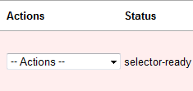

  - Convert selection list to purchase order

Use the Actions menu to convert a selection list to a purchase order.

- From a selection list, click Actions → Create Purchase Order.

- A pop up box will appear.

- Select the ordering agency from the drop down menu.

- Enter the provider.

- Check the box adjacent to prepayment required if prepayment is required.

- Choose if you will add All Lineitems or Selected Lineitems to your purchase order.

- Check the box if you want to Import Bibs and Create Copies in the catalog.

- Click Submit.

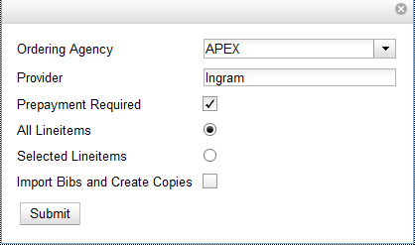

- View/Place Orders

- Open a bib record.

- Click Actions for this Record → View/Place Orders.

- Click Add to Selection List, or click Create Purchase Order.

- See sections 13 and 16 for instructions to proceed.

